Name: __________________________________ Date: __________ Period: ________ Doc #: 10

Level Biochemistry and Graphing Test Review Sheet

- Complete the following table on the four classes of biomolecules:
Biomolecule/  Organic Macromolecules | Subunit/  Building Block | Example | Function | Elements/Structure
Carbohydrates |  | ____________, Starch and dietary fibers | 1.  2. Structural purposes  ex. Chitin, Cellulose | C,H, and O in a 1:2:1 ratio- hexagon shape
 | 3 Fatty Acids and Glycerol | _______, _______ and Waxes | 1.  2.  3. Hormones
 |  | DNA and RNA |  | C, H, O, P and N- 3 parts: sugar base, phosphate group and nitrogenous base
Proteins |  |  | 1.  2.  3. fight disease

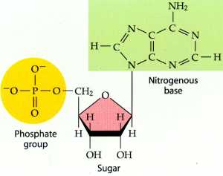
- Underneath each picture, write which biomolecule it is depicting:

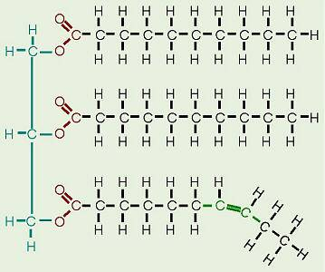
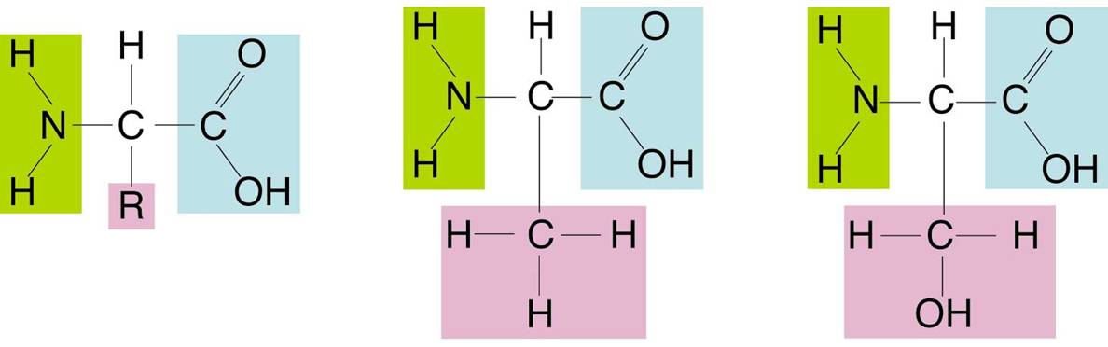
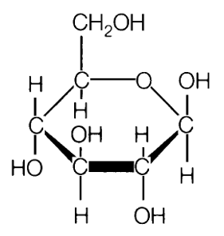

Saturated Fatty Acids

Unsaturated
fatty acid

- What makes each Amino Acid unique? ______________________________________________

- Which biomolecule is our main source of energy? ______________________________________

- Monosaccharide means _____ sugar and an example is ____________.

- Disaccharide means ______ sugars and an example is sucrose.

- _________________ means many sugars and an example is starch.

- Enzymes belong to which of the major classes of biomolecules? ___________________________

- The process that occurs when two molecules join together is known as ______________ _________________. Monomers are joined to make polymers and _________ is lost in the process.

- The process that occurs when two molecules break apart is known as ________________. Polymers are broken into monomers which requires the addition of ____________.

- Which of the above processes would describe the breaking apart of Maltose? _________________

- Define Activation Energy: _______________________________________________________ ___________________________________________________________________________

- A substance that speeds up the rate of chemical reactions is called a _______________________.

- Enzymes are biological ____________ that increase the speed chemical reactions by ___________ the activation energy.

- Roles of enzymes include:
  - Control and manage ___________ ____________
  - Bind to __________ molecules (lactase digests lactose)
  - Work best under ___________ conditions.

- When an enzyme works, the ________________ binds to the ____________ _________ which has a very specific shape. (Bonding sites of Enzyme to Substrate fit like _____________ puzzle.)

- Three things that can affect enzyme function are:
  - _______________ b) _______________ c) _______________

- Use your notes to fill in the following Prefix/Suffixes:
ROOT WORD | MEANING
Mono -
 | Two, Double
Macro
 | Sugar
Bio
 | Many, Much
Hydro
 | To remove
Lysis
 | To make

- Label the Parts of the Enzyme:
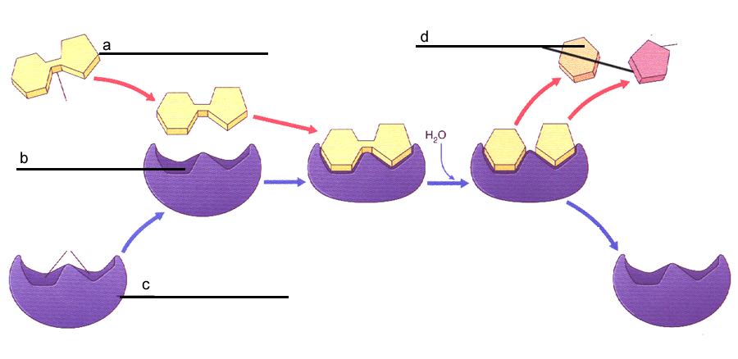

20. The FIVE parts of a graph include:

- _____________ 2) _____________ 3) ____________ 4) ___________ 5) ___________

21. The __________________ variable is the variable being tested and is also called the manipulated variable.

22. __________________ variable is the variable that you measure and is also called the responding variable.

