ORHS Biology Cell Types and Cell Organelles Notes
Name: _________________________________ Pd.______ Date: __________ Doc #: 12

Cell Theory
The cell theory states three facts about cells:
- _________________ are composed of cells
- Cells are the ___________ _________ of living things
- New cells only arise from _____________ _______.
Microscopes revealed the presence of cells and show their detailed structure.
Animal and Plant cells contain _______________ which are “little organs”: small bodies that have a specific structure and function

Important Scientists for Cells
1665: _________________ Came up with the name cells while observing cork from a tree
1674: _________________ Used single-lensed microscope to observe pond water
1838: _________________ Discovered that all plants are made of cells
1839: _________________ Discovered all animals are made of cells

Prokaryotic vs Eukaryotic Cells
The first distinction in different types of cells is whether the cell is prokaryotic or eukaryotic.
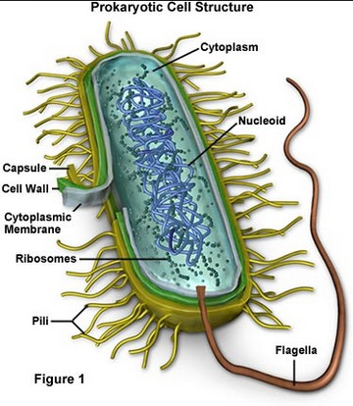
Prokaryotic Cells…
- Are _____________________
- Do not have a ____________
- Have a ______________ with or without peptidoglycan
- Lack membrane bound organelles
- ________________ are prokaryotic cells

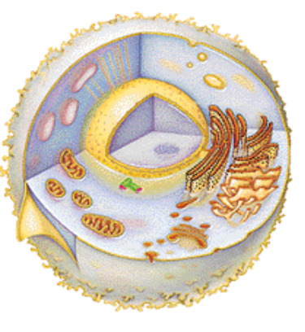
Eukaryotic Cells…
- Are Larger cells
- There is a __________ present
- ____________ cell wall (plants only) or _______(fungi only)
- Contain many organelles
- Have larger ribosomes
- Everything except bacteria (plants, animals, fungi, protists)

Organelles
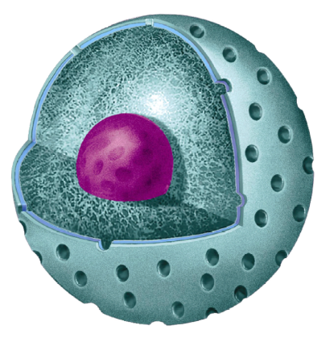
Organelles are parts of a plant or animal cell that have a certain structure in order to carry out a specialized function for the cell.

The Nucleus- _____________________________________
Structure
Large organelle surrounded by a ___________________
Contains pores
Functions
Contains the _______ (chromosomes) and nucleolus
Controls ____________________
Nucleolus makes RNA
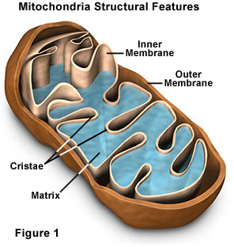
Mitochondria- _________________________
Structure
Usually oval, with a double membrane
Inner membrane (____________) within outer membrane….
inside is called the _____________.
Function
The site of _________ _________, where ATP is made in plants and animals
Important Info
Found in large numbers in cells requiring lots of energy.
Powerhouse of the cell
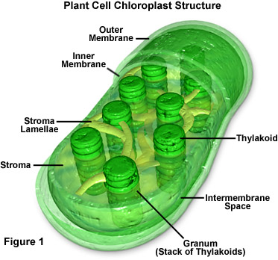
Chloroplasts- ____________________
Structure
Small, flattened structure found in plants.
Surrounded by double membrane; has inner membranes inside
(thylakoid membranes)
Contain __________________
Function
Site of _______________ (changing sunlight into glucose)

Endosymbiotic Theory ‘Where did cells come from?”
Chloroplasts and Mitochondria are particularly specialized organelles as they contain ____________ and have complex membrane structures. Because of these complexity of these cells, scientists have a theory that these organelles are actually descendents of ________________________ that were engulfed (or taken in) by early eukaryotic cells.
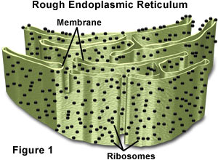
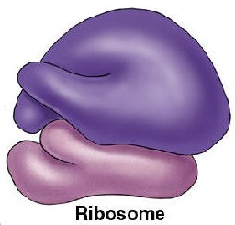
Ribosomes- __________________________
Structure
Very small organelle
Can be ___________________ or can be attached to the ER
Function
Site where _____________ are made (___________________)

Endoplasmic Reticulum (ER)-__________________________
Structure
System of _________________ (channels and tubular canals) enclosing a fluid filled space
Surface of rough ER is covered with ________________
Function
______________________ which have been made in the ribosomes.
Smooth ER | 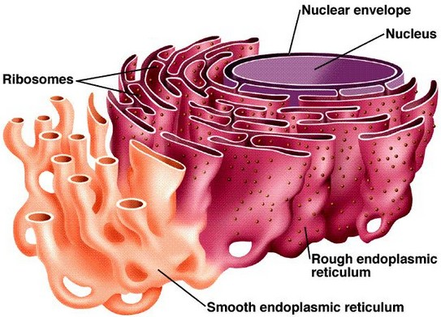 | Rough ER
- No ribosomes present  - Makes and transports lipids.  - Detoxify drugs in the liver. |  | - Ribosomes are attached  - Makes proteins the cell to export  - Modified the content  - Forms vesicles and carries content to the Golgi
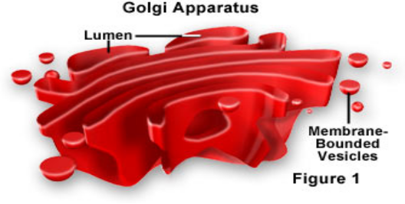
The Golgi Apparatus- _________________
Structure
Group of smooth endoplasmic reticulum that have _____________
_____________ are often seen at the edges
Functions
________________________________ substances that
are produced by cells (mainly proteins and glycoproteins)
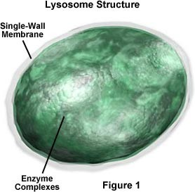
Makes ______________

Lysosome- ____________________________
Structure
Round organelle surrounded by a membrane
Function
Contains ______________________ that are used to
Breakdown macromolecules into small molecules the cell
can use or digest invading cells or to destroy the cell if
it needs to be replaced (so it’s also called a Suicide Bag!)

Vacuoles- _____________________
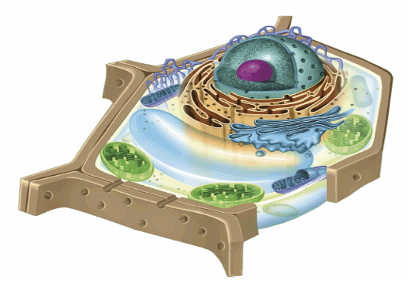
Structure
Membrane enclosed sacs for storage.
Function
Stores materials such as ________________________________
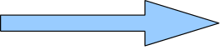
Important Info
Plant cells contain _____________________ which provides
support in the form of Turgor Pressure

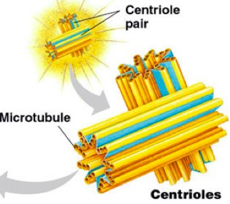
Centrioles- ___________________
Structure
Paired structures located near nucleus
Only visible when the cell is ready to_________
Function
Helps organize _________ _________
Important Info
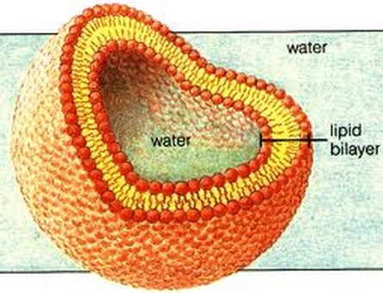
Not found in plant cells

Cell Membrane- __________________ (Also called the plasma membrane)
Structure
Found on the surface of animal cells and just inside cell wall of plants
Made of _______________________
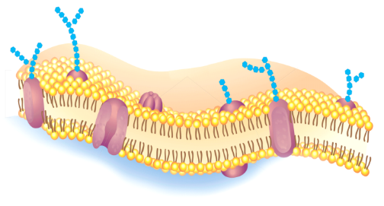
Functions
Regulates __________________________________
Also provides _____________________________
Has receptor molecules to respond to chemicals

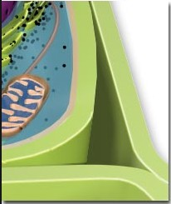
Cell Wall: _______________________________
Structure
A rigid structure that ______________________.
Made mainly of cellulose (a carbohydrate)
Functions
______________________plant cells
Plant cells have a cell wall in addition to a cell membrane.
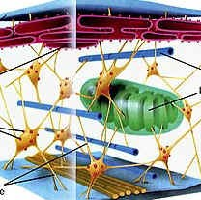

The Cytoskeleton- _________________________
Structure
Supporting structure and transport system
Network of protein filaments
Function
Helps the cell to keep its ____________
Also helps cell move using things called ____________ and ______________

Plant vs Animal Cells
Plant and Animal cells are both eukaryotic cells. But they have many structural and functional differences.

Plant Cells… | Animal Cells…  ANIMAL CELL
- Have a cell wall made of ____________  - Have one large ________________  - Contain __________________ | - Have no ________________  - Have many ___________ vacuoles  - Have no chloroplasts
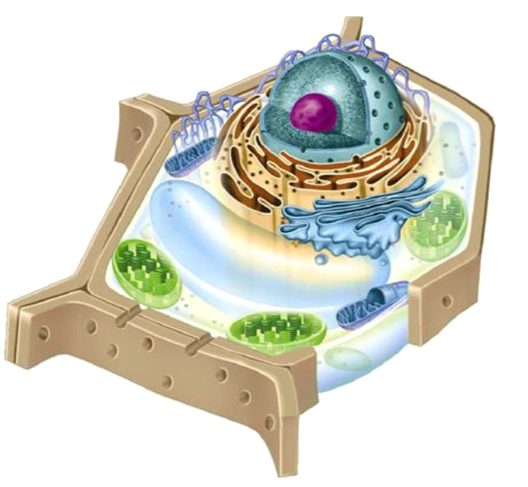
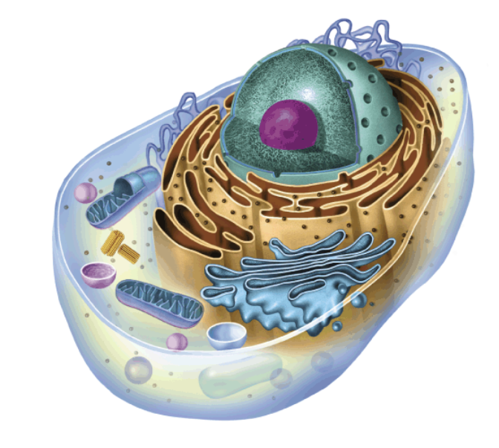
PLANT CELL
ANIMAL CELL

