Name _________________________________________ Doc#: 17

The Cell Membrane and Cell Transport Notes

Cell Membrane: Structure and Function
- The Cell Membrane is the outer living boundary of the cell.
- It gives the cell _______________ and __________________
- It regulates the passage of molecules ________, and __________, the cell
- Is composed of a _______________________________ in which proteins are embedded.
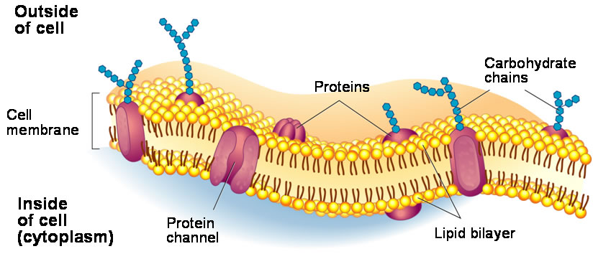

Fluid Mosaic Model
- The cell (or plasma) membrane can often be referred to as the _____________________.
- It gets this name because the membrane moves and flows between extracellular and intracellular fluids allowing things to pass through _____________________ its structure.
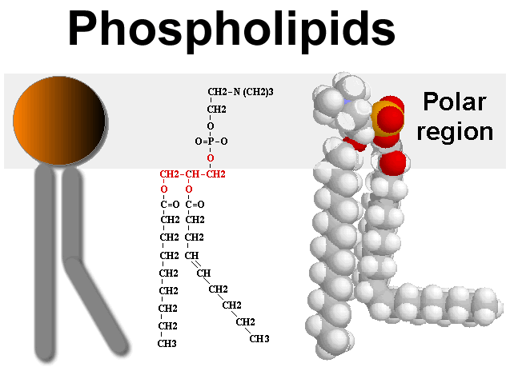
Membrane Bilayer

Phospholipids
- Have polar and nonpolar regions.
- Have ________ and ______________________.
- The head is _________ and therefore, is _____________________________.
- This makes them hydrophilic.
- The tails are ______________, therefore the tails push ___________________.
- This makes them hydrophobic.
- _____________=water loving _____________= water fearing
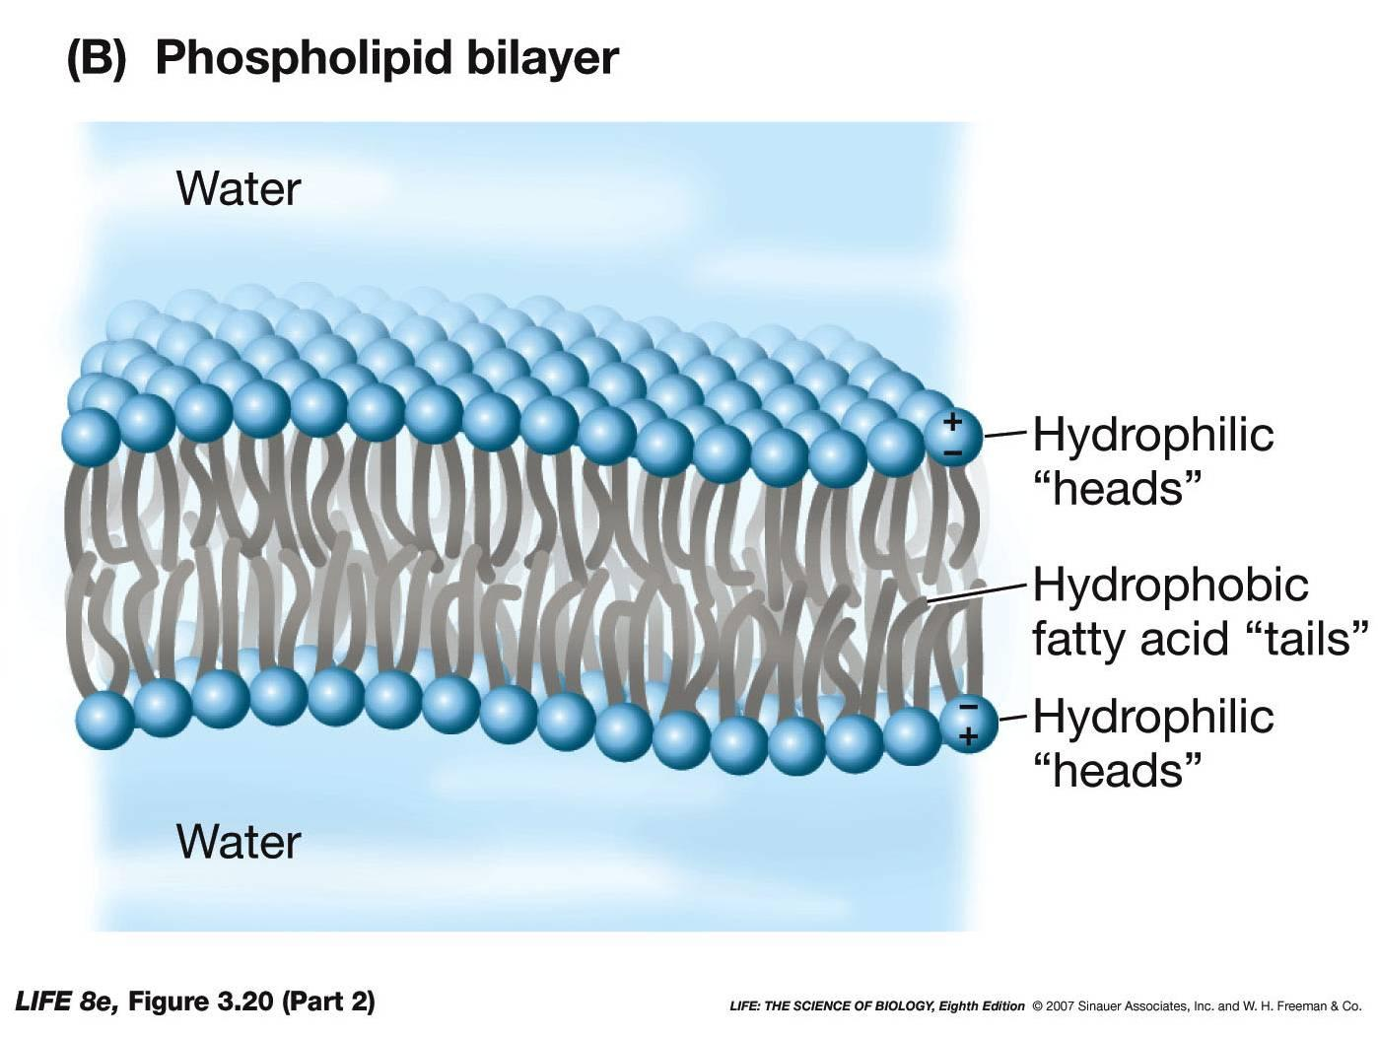
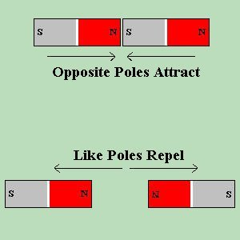
- The reason the _____________ is _____________________ and not one is because there is water on the outside and on the inside of the cell. The heads can touch the water, while the tails cannot. Therefore, two layers of phospholipids come together so that the tails can turn inward and away from water.

Polar vs. Non-polar
- _________ means that the substance has both positive and negative poles (ends)
- ________________means that the substance has a balance of positive or negative poles.
- Polar things like other polar things. Water is polar.
- Nonpolar things like other nonpolar things. Oil is nonpolar. That is why oil and water do not mix!!

Cell Membrane Proteins

____________ can fit in the membrane because they have a _______ region and a _________ region (just like the phospholipids). Nonpolar regions _____________ in the membrane, and the polar regions _______ __________ the membrane.
- _____________________ Proteins also called _____________ Proteins
Marker proteins ____________ similar cells and dissimilar cells that are nearby
- ____________ Proteins: allow the ____________ of a specific molecule or ion to travel freely across the cell membrane through a built in ____________ in the protein
- _____________ Proteins: have a specific shape that will allow a particular molecule to ______to it and _______ the cell
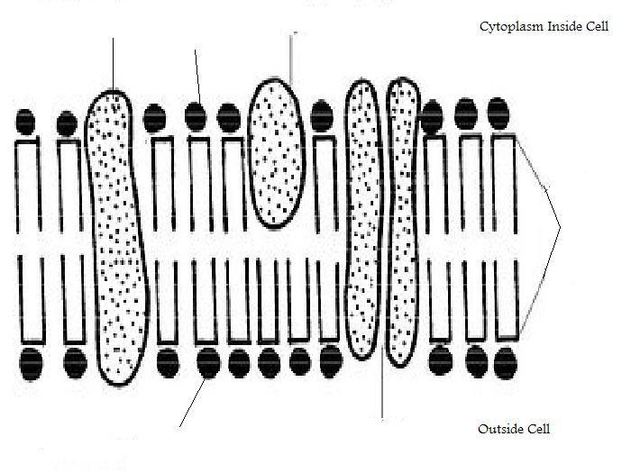
Some proteins in the cell membrane have carbohydrate chains attached to them. These proteins can act either as markers for recognition or receptors for communication.

Cell Transport
Homeostasis
- Homeostasis is a process by which organisms maintain a relatively _________ internal environment
- Molecules are ______________________ in order to achieve this stable balanced environment.
- When the equal balance is achieved, we call this _______________. Afterwards, molecules continue to move about, going back and forth, at all times.
- A net movement is the term used to describe the ____________ the majority of molecules are ______________.
- If homeostasis fails, trauma or _____________________ is the result.

Selectively Permeable
- To reach ________________, molecules must move ____ and _____ of cells.
- Not all molecules can travel through the cell membrane.
- Some molecules are too __________ to fit through the membrane, so _____________ ______________ will move instead to achieve equilibrium (balance out concentrations)

Passive Transport
- Passive transport occurs when molecules move freely across the membrane _____________ using ____________________________
- Examples of this are: 1) Diffusion, 2) Osmosis, 3) Facilitated Diffusion

What is a concentration gradient?
- A concentration gradient refers to the amount of substances or molecules in two separate areas.
- Naturally molecules move _______ (with) the gradient from _________________
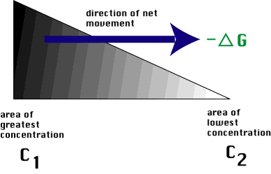
- Sometimes molecules need to move ____ (against) the gradient from _______________ and energy is needed

Diffusion
- Diffusion is the net movement of a substance from an area of _______________________ to an area of ________________________ (down or with their concentration gradient).
- Once they are _________ distributed, they continue to move about, but there is ________________________ of either one in any direction.
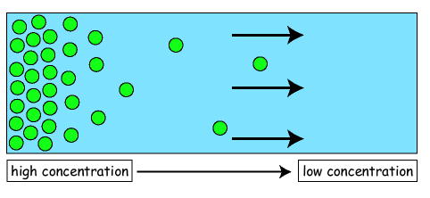

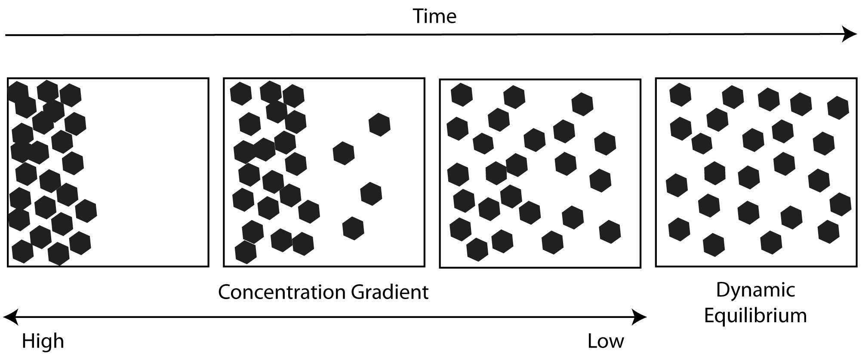

Facilitated Diffusion
- Facilitated diffusion moves molecules _____________ a concentration gradient, so no energy required.
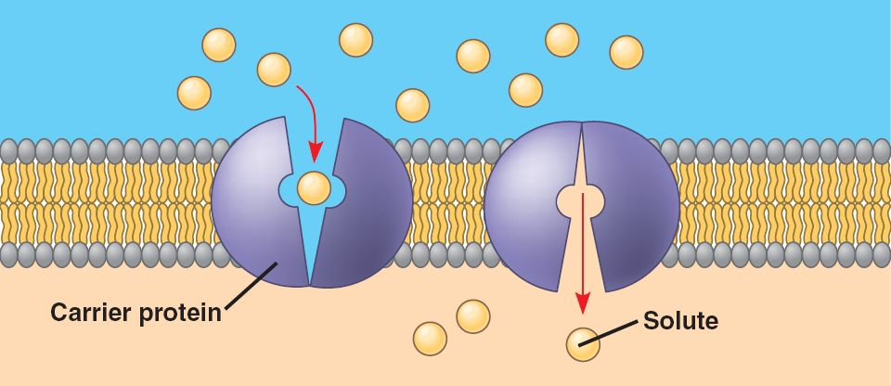
- A ___________________________________ speeds the rate at which a molecule crosses a membrane.

Osmosis (a type of diffusion)
- Osmosis is the __________________________ across a selectively permeable membrane.
- _________ is a substance that is able to move freely in and out of cells.
- Osmosis is a type of diffusion that ______ occurs with _________. While many particles may diffuse through different mediums, the following terms for the tonicity of a solution will only be used in reference to ____________ and the diffusion of water. They only describe the SOLUTION that the cell is in, not the cell itself.
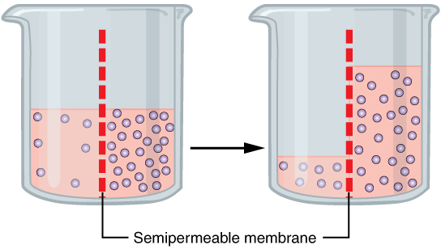

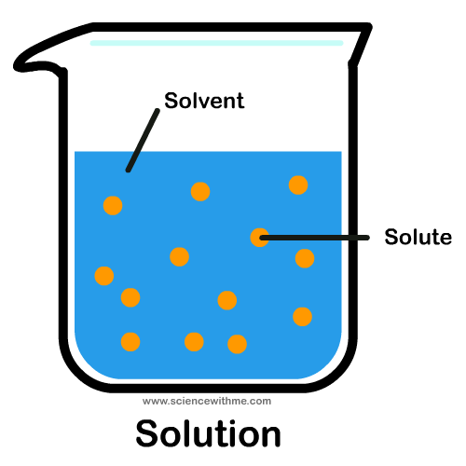
Solutions, Solutes, and Solvents
- A solution __________________________________________________.
- The _____________ is the dissolved substance (Kool-aid mix, salt, or sugar)
- The _____________ is the dissolving substance (water)

Tonicity of Solutions (OSMOSIS ONLY)
Tonicity- measure of the __________ pressure
Tonicity of Solution | Concentration of Solute | Water | Net Movement | Effect
Isotonic | ________ as cell | _______ as cell | None
Hypotonic | ______ than cell | ______ than cell | Cell _____ water | ____________  Turgor Pressure
Hypertonic | ______ than cell | _______than cell | Cell _____ water | ____________  Plasmolysis
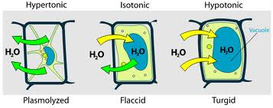

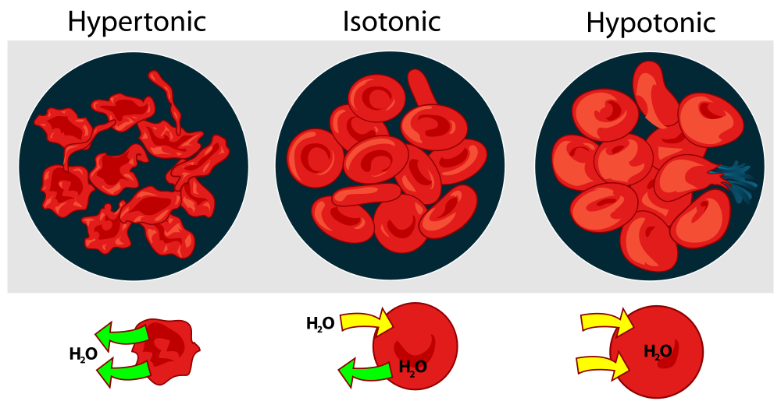

Isotonic Solutions
- ___________ concentrations of all molecules on both sides of the membrane.
- There is no net movement and the cell is __________.

Hypertonic Solutions
- Higher solute concentration OUTSIDE the cell.
- Water (solvent) will move from inside the cell to outside the cell in order to balance out concentrations.
- End result = ____________________

Hypotonic Solutions
- Higher solute concentration INSIDE the cell.
- Water (solvent) will move from outside the cell to inside the cell in order to balance out concentrations.
- End Result = ____________________ and eventually bursts.

PRACTICE
Cells want to be at equilibrium with their environment. If a solution has a higher solute concentration (less water) than the cell, the _________________________ into the solution it is in, to try to make the ratio of solute to water the same outside of the cell as the inside of the cell. This causes the cell to shrink (because it is losing water).
ENVIRONMENT: 10% WATER

CELL: 90% WATER
Draw arrows showing the movement of the water and label the tonicity of the solution.

The solution is: _____________

Cells want to be at equilibrium with their environment. If a solution has a lower concentration of solute (more water) than the cell, ________________________ the cell, to try to make the ratio of solute to water the same outside of the cell as the inside of the cell. This causes the cell to grow and potentially burst (because the cell is gaining water)!
ENVIRONMENT: 70% WATER

CELL: 30% WATER
Draw arrows showing the movement of the water and label the tonicity of the solution.

The solution is: _____________

Cells want to be at equilibrium with their environment. If a solution has an equal amount of solute (more water) than the cell, ______________________________ the cell with ___________________, keeping the ratio of solute to water the same outside of the cell as the inside of the cell. The cell will not change.
ENVIRONMENT: 50% WATER

CELL: 50% WATER
Draw arrows showing the movement of the water and label the tonicity of the solution.

The solution is: _____________

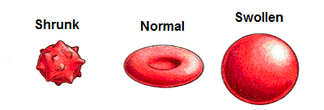
Label the type of solution each cell would be in:

Active Transport- against the gradient
- Active transport is an energy-requiring process that moves molecules _________________________ a concentration gradient
- The net movement is from a low concentration to a high concentration
- This transport requires a _______________________________
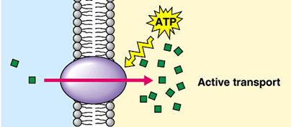

Types of Transport – Summary
- Passive
  - Diffusion – includes Osmosis
  - Facilitated Diffusion
- Active
  - Active Transport
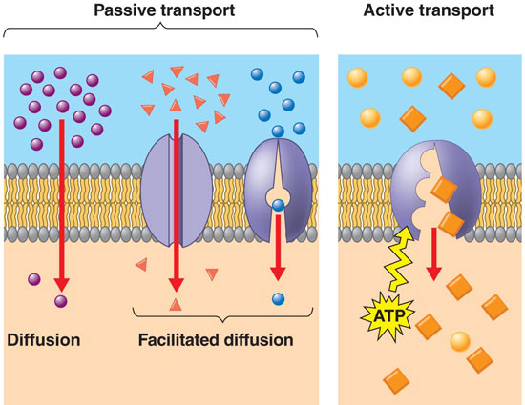
Transport | Description | Energy
Diffusion | _____ _____________ squeeze through cell membrane. Ex: Oxygen | NO
Osmosis | The diffusion of ________. | NO
Facilitated Diffusion | A ________ _________ is used to transport molecules across cell membrane. | NO
Active Transport | A ________ ________ uses ATP to move molecules against the concentration gradient | YES

Endocytosis
- The cell membrane ___________structures that are too _________ to fit through the pores in the membrane.
- In this process the membrane itself wraps around the particle and pinches off a ______________inside the cell.

Exocytosis
- The opposite of endocytosis is exocytosis. Large molecules that are manufactured in the cell are _______________ through the cell membrane in a vesicle.
- Some particles are small enough to diffuse directly through the cell membrane. The ________ _____________ must be released through exocytosis.

Pinocytosis and Phagocytosis
- Pinocytosis (_________________)- fluid taken into cell
- Phagocytosis (________________)- particles taken into cell

