Name: ___________________________________ DOC #: 27

DNA, CELL CYCLE & MITOSIS
LEVEL TEST REVIEW

USE your notes (#25), the DNA Coloring Sheets (#26a, #26b), and the Cell Cycle Review Picture (#28) to help you answer the following questions.

Part 1: DNA STRUCTURE AND REPLICATION

1. DNA stands for _______________________________________

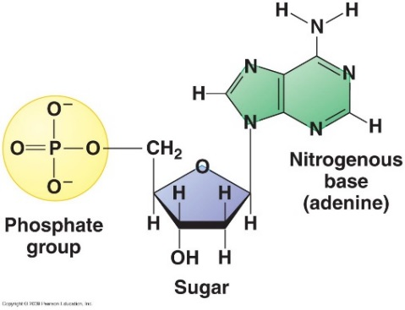
2. Label the parts of the nucleotide with the following labels: phosphate group, deoxyribose sugar, nitrogenous base

3. The nitrogen bases bond down the center of a DNA molecule using _________________ bonds.
a) Covalent
b) Phosphodiester
c) Oxygen
d) Hydrogen

4. DNA is a code for the making of proteins. The code comes from the order of the ______________
a) phosphate groups
b) deoxyribose pairs
c) nitrogen bases
d) hydrogen bonds

5. When DNA replicates, each strand creates contains one old strand and one new strand. This method of replication is called:
a) semi conservative
b) anti-parallel
c) Okazarki fragments
d) partial duplication

6. All living things have DNA. For eukaryotes, DNA is located in the __________________, while for prokaryotes, it is located in the __________________.

7. When the bases bond in the center of DNA, they require different numbers of H bonds, depending on which two bases have joined together. Between A and T there are __________ H bonds and between C and G there are __________ bonds. The bonds between the bases are in the center of the helix and make up the _________ (another name for steps) of the ladder. The bonds between the sugar and phosphates are on the sides of the ladder and often called the _____________.

8. The two bases that are considered to be purines are _______________ and _______________. The two bases that are considered to be pyrimidines are ____________ and _________________.

9. Label the picture of DNA with the following labels: Strong Backbone bonds, Hydrogen bonds, phosphate groups, deoxyribose, nitrogen bases
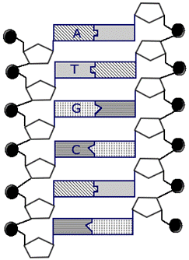

10. Fill in the table about the important Scientists in the discovery of DNA:
SCIENTIST/S | CONTRIBUTION | MEMORY CLUE
 | Confirmed that DNA is the genetic material with an experiment with viruses. | The chase was on to find the genetic material! When they found DNA, they celebrated with Hershey’s bars!!
 | Studied DNA with X-ray | Sad story that SHE got ovarian cancer from all the X-ray exposure
 | Discovered in DNA the # of As always equaled the # of Ts (same for C and G) | He made Bar Graphs to study DNA!
 | Built a model of DNA as a spiral staircase | What a Crick I have in my neck from building this DNA model

11. Complete the following DNA strands, using what you understand about complementary base pairing
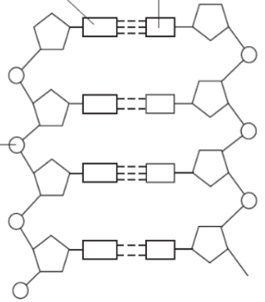

G
G

a) b) c)

C

T
A
A

C
C

G

T
T
A

12. DNA Replication occurs during the _________ phase of the cell cycle. DNA replication must happen BEFORE a cell begins to divide so that each daughter cell has a FULL SET of DNA.

13. DNA replication involves the work of 4 enzymes. Fill in the chart explaining the role of each of the 4 enzymes:
ENZYME | FUNCTION | NICKNAME | REASON FOR NICKNAME
 | Breaks the Hydrogen bonds in the original strand of DNA |  | Because she breaks up bonded couples
 | Brings in the matching bases to make the complimentary strand; proofreads the new matches |  | Because she finds appropriate new partners for the recently broken up
 | Sticks the bases together using Hydrogen bonds and seals the ends of the DNA strands |  | Because she causes the new couples to bond together for life
 | Winds the DNA molecules back into a double helix |  | Because she teaches the new strands how to twist
WORD BANK:
Enzyme Choices are: GYRASE, LIGASE, HELICASE, DNA POLYMERASE
Nickname Choices are: DANA THE DATE MATCHMAKER, GINA THE GYMNAST, LISA THE LOVE SPELL, HELEN THE HOMEWRECKER

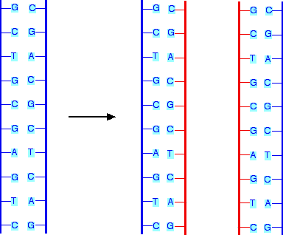
14. Fill in the missing bases on the two new strands of DNA created by DNA replication

Part 2: THE CELL CYCLE
15. The Cell Cycle can be divided into TWO main parts. _________________ which includes G1, S and G2 and prepares the cell to divide. Then Cell Division or _____ phase in which the cell goes through steps to actually divide.

16. Cell Division occurs in 2 parts:
1. MITOSIS: Division of the _____________________ (nucleus or cytoplasm?)
2. CYTOKINESIS: Division of the ___________________ (nucleus or cytoplasm?)

17. Label the Cell Cycle, using the WORD BANK BELOW.
 | NAME OF PHASE | HINT
A |  | Cell Grows
B |  | DNA Replicates
C |  | Cell Prepares to divide
D |  | includes A, B, and C  In between divisions
E |  | PLEASE
F |  | MAKE
G |  | ANOTHER
H |  | TOUCHDOWN!!!
I |  | Cytoplasm Divides
J |  | 4 phases: E, F, G, H
K |  | Includes Mitosis and Cytokinesis
L |  | Cell Rests
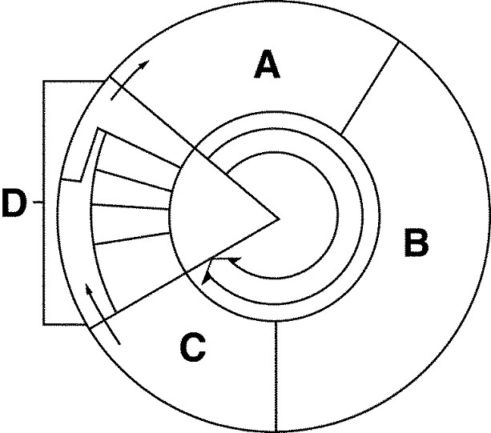

L
A.

IH____________________
(note: includes A, B, and C)
HH____________________
(note: includes A, B, and C)
K.
G____________________
(note: includes A, B, and C)
D. ____________________
(note: includes A, B, and C)
JH____________________
(note: includes A, B, and C)
F ____________________
(note: includes A, B, and C)
B.
EE____________________
(note: includes A, B, and C)

C

WORD BANK
-Prophase -G1 -Interphase -Telophase
-Metaphase -G2 -Mitosis -S Phase
-Anaphase -G0 -Cytokinesis -M Phase/Mitosis

18. The purpose of checkpoints in the cell cycle are
a) to make the cell cycle take longer
b) for DNA replication to happen during checkpoints
c) to cause cancer
d) to ensure there are no errors and prevent replication of unhealthy cells

19. During G0, a cell will
a) rest
b) replicate its DNA
c) check for errors
d) grow

20. If a cell is unable to stop dividing and the checkpoints fail, ____________ will develop:
a) Alzheimer’s Disease
b) Cancer
c) Stroke
d) Homeostasis

21. There are two types of tumors. ________________ (Malignant or Benign?) tumors have not metastasized or broken off and spread, they have remained contained in one area and are less harmful. ______________ (Malignant or Benign?) tumors have metastasized, meaning cells have broken off from the original tumor and spread to other areas of the body.

22. At the end of cell division, one parent cell has become:
a) Two identical daughter cells
b) Two non-identical daughter cells
c) One identical sister cell
d) Four identical sister cells

23. TRUE or FALSE- highlight or underline which you choose
TRUE or FALSE Cytokinesis is the last phase of Mitosis
TRUE or FALSE DNA replicates during G2
TRUE or FALSE Your Brain and Heart Cells remain in G0 throughout your lifetime
TRUE or FALSE The NUCLEUS divides during Mitosis
TRUE or FALSE S Phase is part of Interphase
TRUE or FALSE Cells spend more time in Cell Division than they do in Interphase

22. Fill in the following chart on the phases of CELL DIVISION. For each description or picture you are labelling which phase is occurring:

P- PROPHASE M-METAPHASE A- ANAPHASE T- TELOPHASE C- CYTOKINESIS
DESRCIPTION/PICTURE | PHASE OF CELL DIVISION | DESRCIPTION/PICTURE | PHASE OF CELL DIVISION
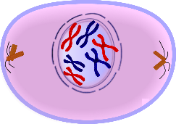  a) |  | 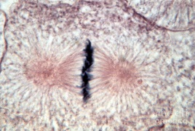  b)
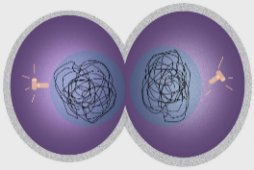  c) |  | d) Chromatin coils to form chromosomes, the nuclear membrane breaks down
e) The SECOND phase of MITOSIS |  | 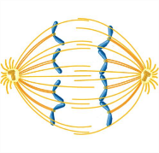  f)
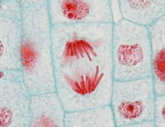  g) |  | 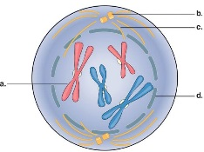  h)
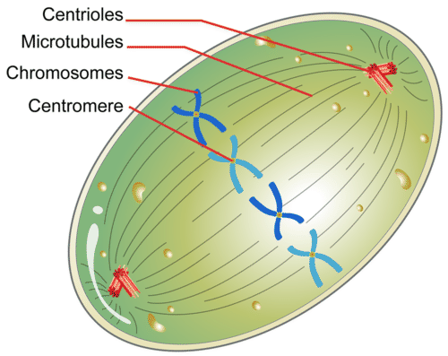  i) |  | j) The last official phase of MITOSIS, the nucleus has now been divided
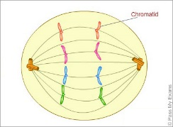  k) |  | 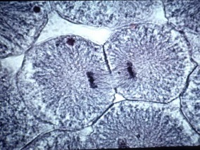  l)
m) Spindle fibers form, centrioles take their place at opposite sides |  | 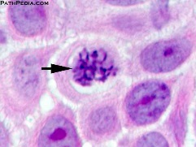  n)
o) The Cytoplasm splits and two daughter cells form |  | p) Chromosomes line up across the middle of the cell
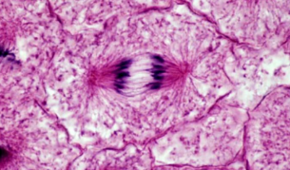  q) |  | 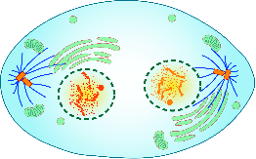  r)
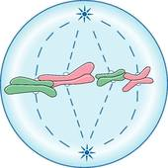  s) |  | t) Sister chromatids separate into individual chromosomes and are moved to opposite sides of the cell

23. At the end of mitosis, the goal is for each new DAUGHTER nucleus to have the exact same number of chromosomes as the original PARENT nucleus. Use that info to complete the following:

If the parent cell had 8 Chromosomes, each new daughter cell would have ____________ chromosomes
If the parent cell had 23 chromosomes, each new daughter cell would have ___________ chromosomes
If the parent cell had 5 chromosomes, each new daughter cell would have ____________ chromosomes

IDEAS FOR HOW TO STUDY MORE AT HOME BEFORE THE TEST
- Go back over this sheet and make sure you understand every question, particularly those you originally got wrong
- Go back over your VOCABULARY QUIZ and correct it! Then you can study those vocab words again playing the Quizlet or Quizzizz games made by your teacher
- Read back over your notes and study the Cell Cycle Review Diagram. Highlight the memory clues that will help you remember for the test
- Watch the relevant Amoeba Sisters videos: Mitosis, Cell Cycle and Cancer, DNA Replication (you can google these or find links on a Biology teacher’s website). Review videos made by Biology teachers can also be found on their websites.
- Play the test review Quizzizz sent out by your teacher on Remind

