## **Name: ______________________________ Date:__________________ Doc # 30**

**Protein Synthesis: Transcription & Translation Notes**

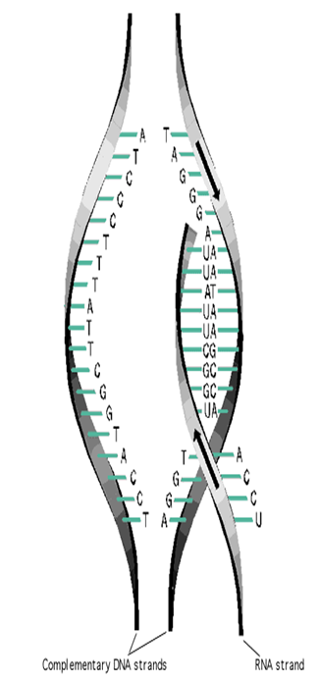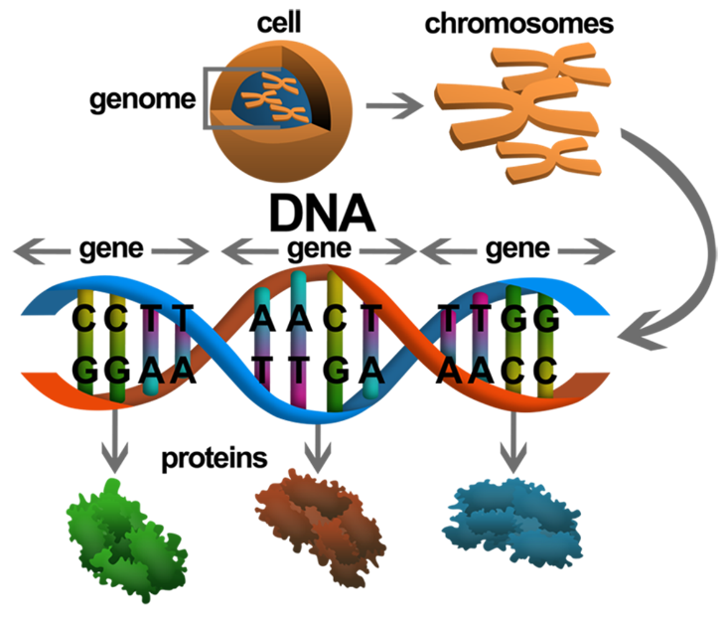The overall goal of protein synthesis is to make proteins, which are needed everywhere in our body in order to function.

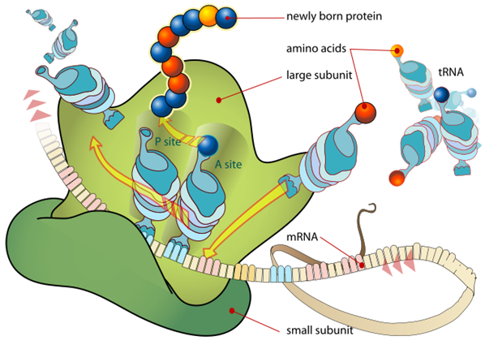

There are two parts to protein synthesis 1) 2) .

DNA is a blueprint that makes you who you are.

More specifically, it is the blueprint to make RNA or _______________________.

|  |  |
| --- | --- |
| **DNA** | **RNA** |
| ________________ stranded | ________________ stranded |
| Adenine – Thymine | Adenine - ______________ (Thymine is replaced) |
| Cytosine – Guanine | Cytosine – Guanine |
| ___________________ sugar | ___________________ sugar |

**Transcription**: The copying (writing) of DNA to form _______.

* mRNA-________________ RNA, carries the DNA code for the protein to the ribosome.
* 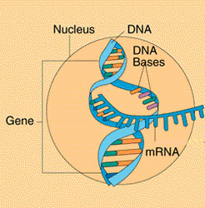tRNA – _______________ RNA, carries amino acids to ribosome to construct the protein.
* 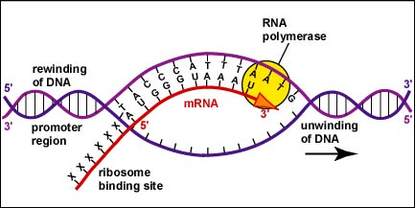rRNA - _______________ RNA, makes up ribosomes.

* Transcription occurs in the _______________ of Eukaryotic cells.
* DNA cannot leave _____________ because of its size, therefore genetic information must be copied into smaller pieces
* These small sections of DNA are called genes and are copied into _______________________.

**Steps in Transcription**

1. **Helicase:** ________________ DNA helix
2. **RNA Polymerase:** ____________ and _______________ free floating RNA nucleotides to DNA. These free nucleotides once put in order forms the RNA. When it reaches the stop sequence, polymerase detaches and RNA is free.

3.  **Ligase:** _______ back the bases in the DNA Helix with hydrogen bonds

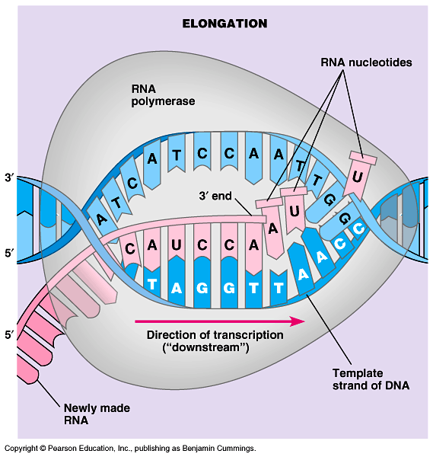4. The RNA strand, now called mRNA, leaves the DNA molecule and the nucleus.

5. **Gyrase:** ______________ up the DNA strand.

Transcribing rules: **DNA to mRNA**

A to ___ T to ___

C to ___ G to ___

**Let’s Practice:**

**DNA:** A A T C C G G C G T A T

**mRNA:**

* Now that the RNA strands are written (transcribed) they are sent out of the nucleus and into the cytoplasm of the cell.
* Once in the ______________, the mRNA finds a ____________- our protein making factories.

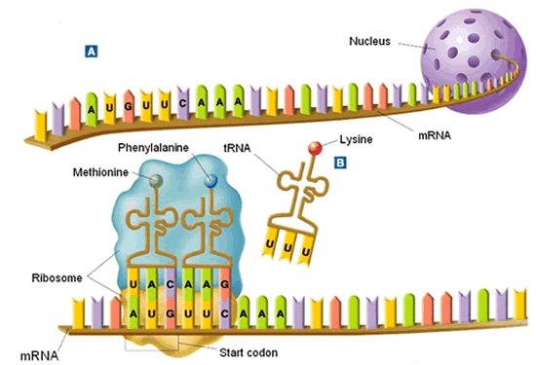**Translation**: _______ is used as a written code to form ________________.

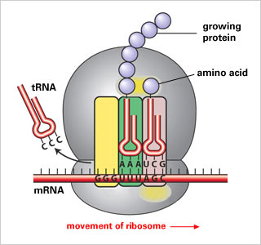

* During translation mRNA works with other types of RNA to build _____________ by joining _______________________.
* The genetic code is the connection between nucleotide triplets in _______ to ______________________ to ______________.
* Every __________ nucleotide bases in mRNA specify a particular _________________.
* 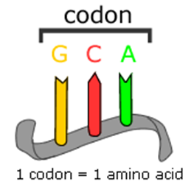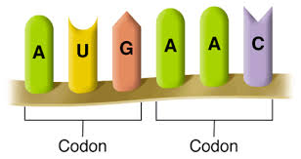This nucleotide triplet is called a ___________.

**9 bases**= ___ codons= 3 Amino Acids **15 bases**=___ codons= 5 Amino Acids **3 bases**= ____ codon= 1 Amino Acid

* The _____________________________ in a codon determines an amino acid.
* The specific order of amino acids in the amino acid chain will determine the _____________.
* There are ________ possible codons but only ______different amino acids.
* More than one codon may specify an amino acid. “STOP” codons specify the end.

Circular Codon Chart Rectangular Codon Chart

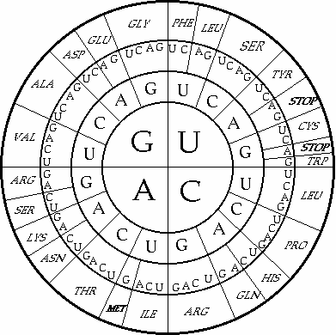

ISO

TRY

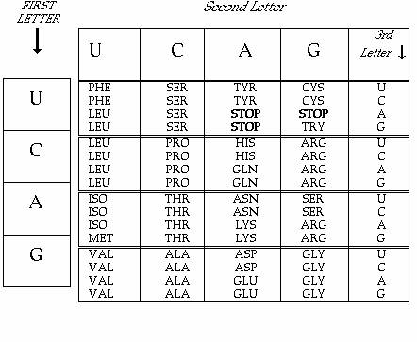



Translating rules: **mRNA to tRNA**

**Let’s Practice**

**DNA:** T A C A A T C C G G C G T A T A C T

**mRNA:**

**Amino Acid:**

**tRNA:**

**U to ___ A to ___**

**C to ___ G to ___**

* 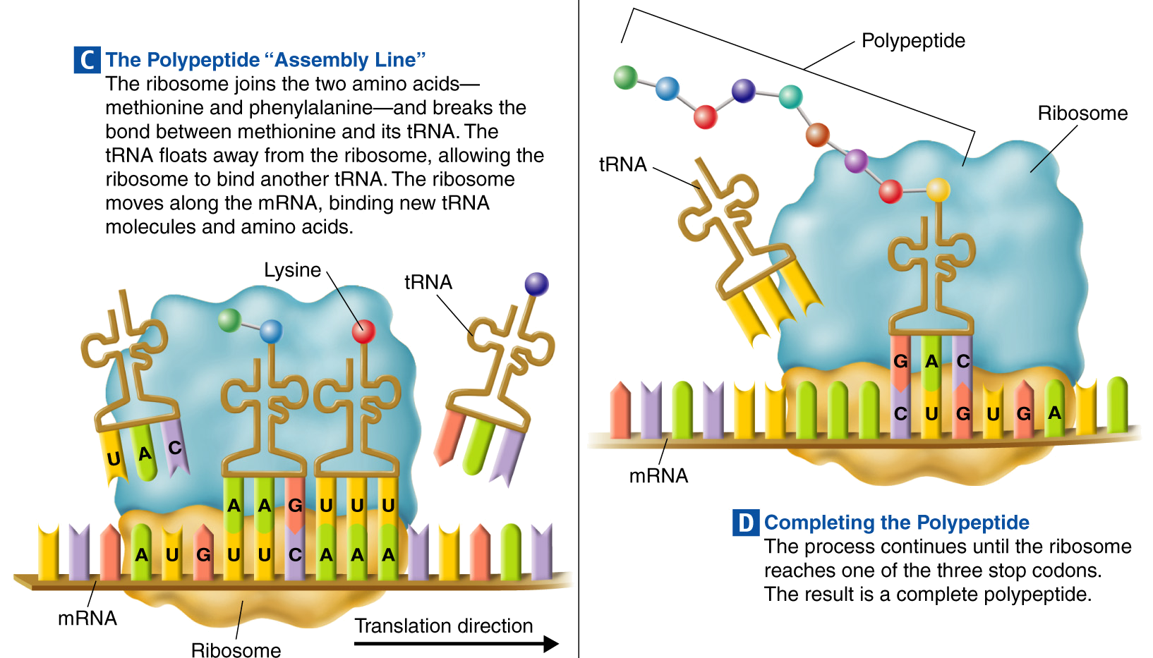

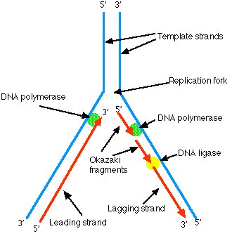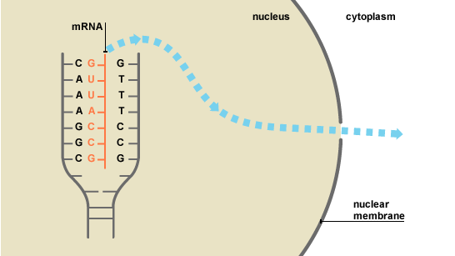Label the following processes:

