Name: _____________________________ Date: ___________ Pd: ______________ Doc #:33

PROTEIN SYNTHESIS ACTIVITY:
Making A Protein Bracelet
Fill out the chart below:
- Transcribe your DNA strand into mRNA codons.
- Use the codon circle to work out which Amino Acids this strand is coding for.
- Use the bead conversion chart on the back of the page to record the color and order of beads in the strand, based on the amino acids.
DNA | TAC | TGG | TCG | CGT | ACG | GCA | GGG | CAG | ACC | CAC | TGT | AGT | CGT | ACA | GCA | GGT | CAA | ACC | ATC
- mRNA
- Amino Acid
- Bead Color
Bead Number | 1 | 2 | 3 | 4 | 5 | 6 | 7 | 8 | 9 | 10 | 11 | 12 | 13 | 14 | 15 | 16 | 17 | 18

Next, use the supplies at the station and make a strand of beads. The beads represent amino acids and your bracelet represents a protein. The shape and therefore function of a protein is determined by the sequence of amino acids.
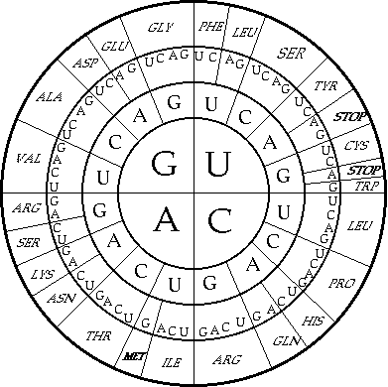

What is the color of the first bead you added? ____________

5th? ____________ 10th? ____________

Your protein gives you a characteristic because,
remember, proteins are important in determining
who we are. When your bracelet is done, check
the Characteristic Key that your teacher has and
determine what characteristic your protein is giving you.

I made a protein that gives me ___________________________.

Abbreviations for Amino Acids and Designated Colors

ALA | ARG | ASN | ASP | CYS | GLN | GLU | GLY | HIS | ILE
Alanine | Arginine | Asparagine | Aspartic Acid | Cysteine | Glutamine | Glutamic Acid | Glycine | Histidine | Isoleucine
Lemon yellow | Coral | Blue | Brown | Red Violet | Neon Yellow | Orange Yellow | Light Purple | White | Black
LEU | LYS | MET | PHE | PRO | SER | THR | TRP | TYR | VAL
Leucine | Lysine | Methionine | Phenylalanine | Proline | Serine | Threonine | Tryptophan | Tyrosine | Valine
Dark Purple | Lime Green | Green | Red | Teal | Pink | Light Aqua | Tan | Gray | Light Blue

