Name: ___________________________________ DOC #: 44

ORHS LEVEL BIOLOGY 2016
Meiosis and Monohybrids Review Sheet

PART 1: MEIOSIS
1. For each statement state whether it describes MITOSIS, MEIOSIS or BOTH
_____________ Creates 4 daughter cells
_____________ Creates IDENTICAL daughter cells
_____________ Undergoes DNA Replication prior to division
_____________ Creates Gametes
_____________ Creates cells with the SAME chromosomes number as the parent
_____________ Cytokinesis divides the Cytoplasm
_____________ Creates Diploid Cells
_____________ Crossing Over occurs during it

PICTURE | D or H? | PICTURE | D or H?
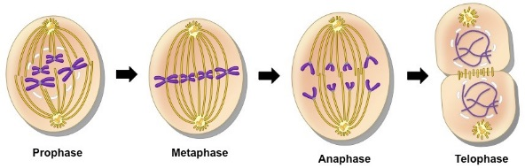 |  | 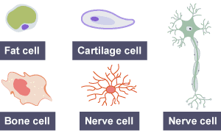
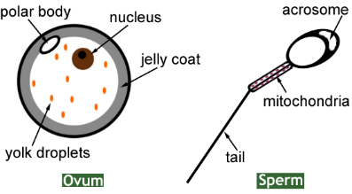 |  | 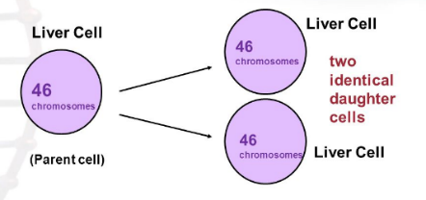
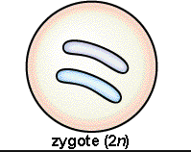 |  | 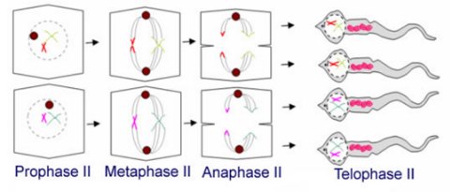
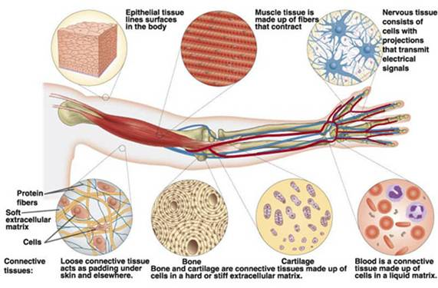 |  | 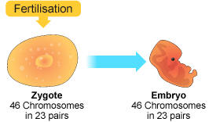
2. For each picture in the chart, does it describes/shows a DIPLOID Cell (D) or a HAPLOID CELL (H)?

3. Meiosis produces non-identical gametes. This feature, and the nature of fertilization, can improve the survival and success of a species because of the increase in:
a) similarity between individuals
b) number of somatic cells
c) genetic variability (differences) between offspring
d) random mutations
4. Complete each statement with the correct Chromosome Number
- If a hamster has 42 chromosomes in its liver cells, it will have _______ chromosomes in its sperm cells
- If a robin has 18 chromosomes in an egg cell, it will have _______ chromosomes in its brain cells
- If a gorilla has 56 chromosomes in a heart cell, it will have ______ chromosomes in its skin cells
- When a fish with 14 chromosomes in its egg cells reproduces with another fish of the same species, the zygote formed will have _______ chromosomes
- When a pig with 22 chromosomes in its lung cells reproduces with another pig of the same species, the zygote formed will have _______ chromosomes
- If a male zebra has 40 chromosomes in a sperm cell, a male zebra of the same species will have ________ chromosomes in a uterine cell
- If a mealworm has 7 chromosomes in its somatic cells, it will have _________ in its gametes
WORD BANK:
- Homologous Chromosomes (used twice)

-Sister Chromatids
(used twice)

-Centromere
5. Label the picture with the terms in the word bank to the side:
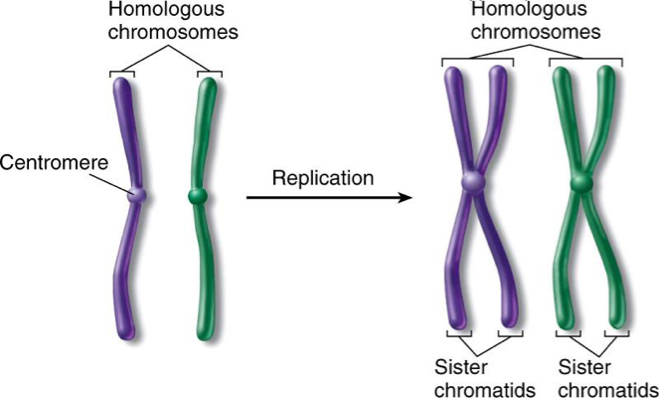

6. For each statement, say whether it is TRUE or FALSE. For False Statements, CORRECT the mistake by crossing out the incorrect word/s and replacing with the correct word/s.
TRUE FALSE Crossing Over occurs during Metaphase II
TRUE FALSE Meiosis creates 4 non-identical somatic cells
TRUE FALSE Independent Assortment increases genetic diversity between gametes
TRUE FALSE A zygote grows into an embryo using the process of mitosis
TRUE FALSE The daughter cells made in meiosis are identical to the parent cell
TRUE FALSE In meiosis, DNA Replication only happens once before Prophase I
TRUE FALSE The uterus that a fetus grows inside of is made up of haploid cells

7. It is necessary to create cells with ________ (half the/ the full) number of chromosomes in Meiosis so that the zygote (fertilized egg) will contain ________ (half the / the full) number of chromosomes.

8. Which of the following is true about a zygote?
a) It is a diploid cell
b) It will begin to grow using the process of mitosis
c) It is the result of the process of fertilization
d) All of the above are true
9. Using TWO different colored markers, draw a Tetrad BEFORE Crossing Over and a Tetrad AFTER Crossing Over (Note: a tetrad is two replicated homologous chromosomes next to each other)
ONE TETRAD AFTER CROSSING OVER
ONE TETRAD BEFORE CROSSING OVER

10. For the pictures below, which one represents MEIOSIS I and which one represents MEIOSIS II.
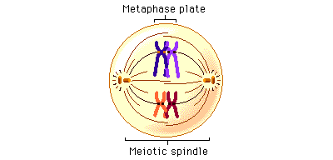
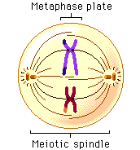

_________________ _________________
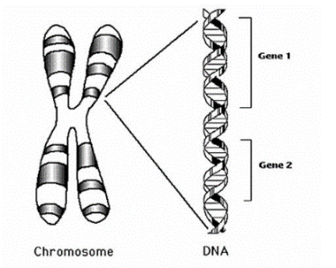
11. Label the picture with the labels: Chromosome, DNA, Gene (used twice)

PART 2: MENDEL AND MONOHYBRIDS
12. The earliest understanding of patterns of inheritance came from the work of a monk named _______________. He did most of work studying crosses between _________ plants.

13. For each of the statements below, write the GENOTYPE of the individual described, assuming that right handedness (R) is dominant over left handedness.
_______ Paul is right handed but his mother is left-handed
_______ Jane is a heterozygote for the trait of handedness
_______ Brian is homozygous recessive for the trait of handedness
_______ Marie is right handed but her daughter is left handed
_______ Jack is right handed with no family history of left handedness
_______ Pedro is left handed
14. For a given trait, there is a sequence of DNA that codes for the trait called a _________. There are two or more possible forms of the gene. These forms are called __________.

15. If you know an organism’s phenotype, will you be able to work out what its genotype is?
a) Yes, the phenotype will always enable you to determine the genotype
b) Sometimes- if the organism shows the dominant phenotype, you can work out its genotype
c) Sometimes- if the organisms shows the recessive phenotype, you can work out its genotype
d) No, you can never know someone’s genotype without genetic screening blood tests

16. Greg has freckles (which is dominant, F) but his mother did not have freckles. His wife Candace does not have freckles and is pregnant with their first child. What are the odds that their baby will have freckles? ________ %

17. Mark and Melissa have three boys. Melissa is pregnant with her fourth child. What are the odds that this baby is another boy? ______ %

18. In dragons, breathing fire (B) is dominant to breathing poison (b). If a purebred female fire breathing dragon mates with a heterozygous fire breathing male, what will be the ratios in the offspring:

Genotype Ratio: _________________
Phenotype Ratio: _________________

19. Sally is highly susceptible to poison ivy (i), which is a recessive trait. She wants to know if her unborn daughter will also have the same recessive trait. Using the punnet squares below, work out which 2 genotypes her husband, George, could have that would result in her daughter showing the recessive trait.

George’s possible genotypes: _____________ _____________
George’s possible phenotypes: _____________ _____________

20. If George is a carrier of the recessive gene, what is the probability that their daughter will be highly susceptible to poison ivy? _________

