DNA Fingerprinting and Cloning Notes

What is Gel Electrophoresis?
Gel Electrophoresis is a technique that can _________ a person’s DNA to create a _______ _______ of bands called their _____ _____________. Because this DNA fingerprint is _______ to only that person (or their identical twin if they had one!), it can be used to _________ the person.

Gel Electrophoresis involves using __________________________ and cut a person’s DNA into fragments. The electrophoresis machine uses _________ currents to separate these fragments into _____________________ of varying lengths that give it a unique bar code appearance.
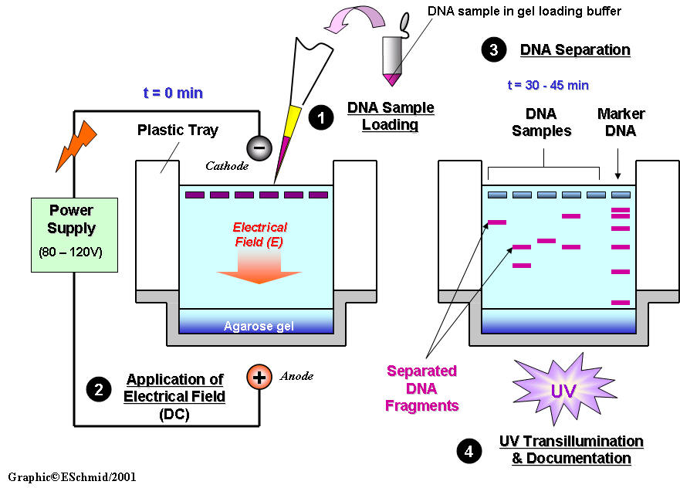
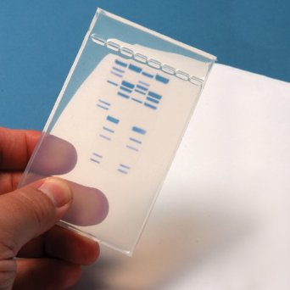

What are some uses for these DNA fingerprints?

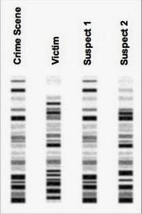
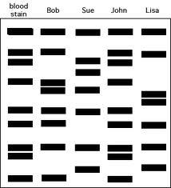
CRIME SCENES: If there is _______________ (blood, hair, fluids) at the crime scene, then they can create a __________________ of that and then collect DNA from the suspects and workout which suspect was _________ at the crime scene. Take a look at the images on the left. In Case 1, John’s DNA matches the DNA from the bloodstain. In Case 2, DNA found at the Crime Scene is a match to ____________.
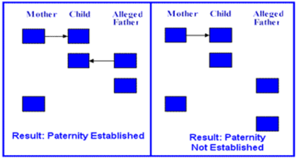
Case 1
Case 2

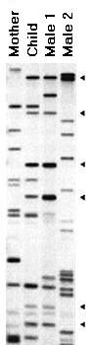
PATERNITY TESTING: DNA fingerprinting can be used to _________ paternity or suggest a more likely paternity candidate. Blood would be needed from the _______, the _________, and the potential father(s). The baby will ______________ _________ to its dad, but it should have only bands seen in EITHER mom or dad. So if the baby had a band that mom did not have, and the potential father also did not have that band, then he could not be the father. If there are multiple potential dads, it would be the one whose bands are _____________ to the child’s bands.

What is Cloning?
Cloning is the process of creating genetically __________ copies. You can clone a single ________ or you can clone an entire ___________ - which would involve copying every single gene of the organism.

Scientists have been experimenting with cloning since the late 1800s. In 1996, Dolly the sheep was the _______________ to be cloned using a __________ transfer from laboratory cells. The diagram below illustrates the process by which Dolly was cloned:

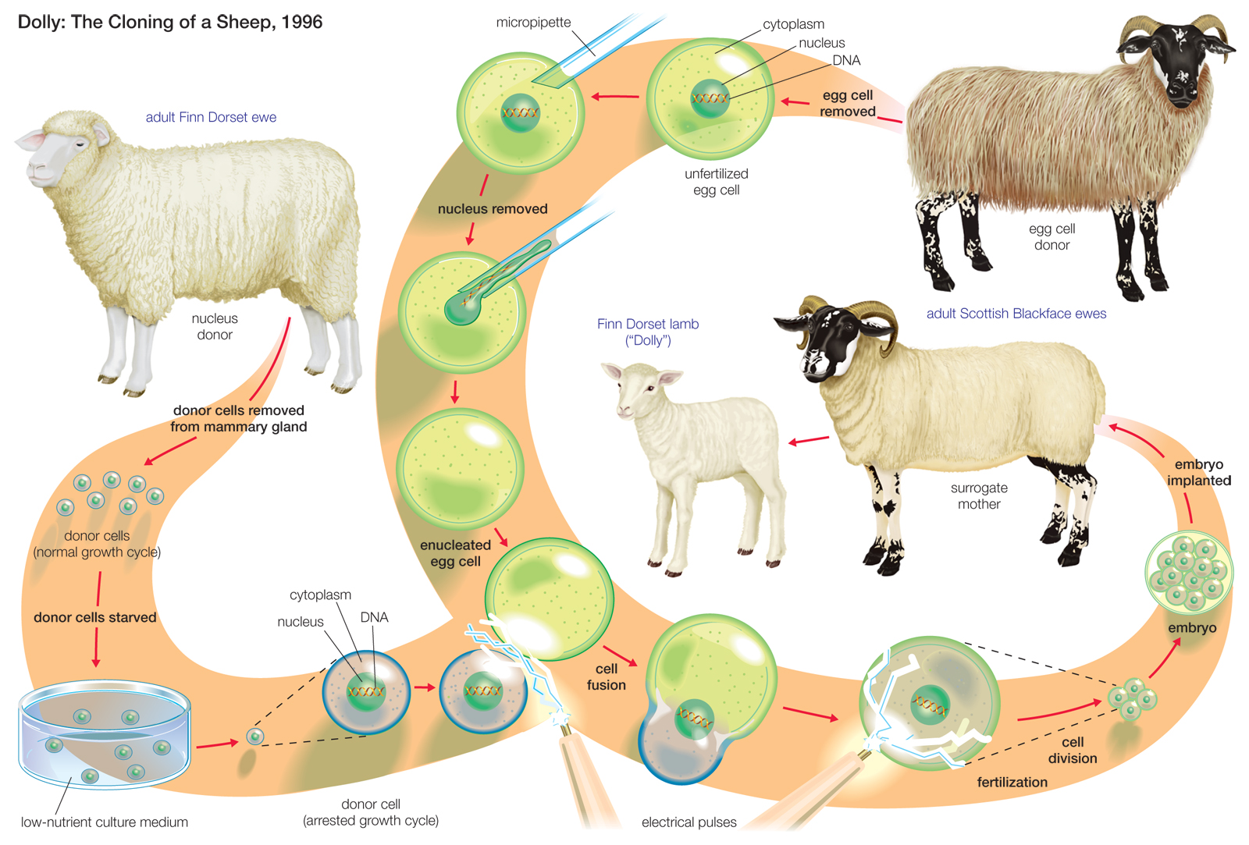

The adult Finn Dorset ewe was the sheep that ______________________, and therefore, Dolly is a clone of this sheep. The adult Scottish Blackface ewe donated an _________ (from which the nucleus/DNA was removed) in which the Finn Dorset’s DNA was inserted. The second Scottish Blackface ewe served as a _____________. In other words, when the embryo reached a certain stage, it was inserted into the Scottish Blackface ewe’s uterus, and although she (like the egg donor) has ______________ relationship to Dolly, she is the one that actually gave birth to Dolly.

The most important point about cloning is that _________________________________________.
So the clone is always an _________ genetic copy of the organism that donates the DNA or nucleus.

