Name: ___________________________________ DOC #: 51
ORHS Level Biology 2016
Non-Mendelian Genetics Test Review

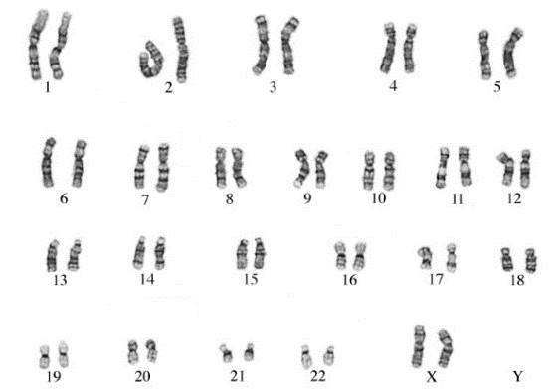
1. Below is an image of all of a person’s chromosomes. This image was taken from a cell undergoing mitosis and is called a _______________ (karyotype or pedigree). This person has a normal number of chromosomes, with no disorders. They have 22 pairs of chromosomes that do not determine gender, also called _______________ (autosomes or sex chromosomes) and one pair of chromosomes that do determine gender called _______________ (autosomes or sex chromosomes).

If a person has XX, they are a _______________ (male or female)

If a person has XY, they are a _______________ (male or female)

2. In the chart below, each karyotype is from a person with a chromosomal abnormality. CIRCLE the chromosome pair that is atypical and then determine the gender of the individual
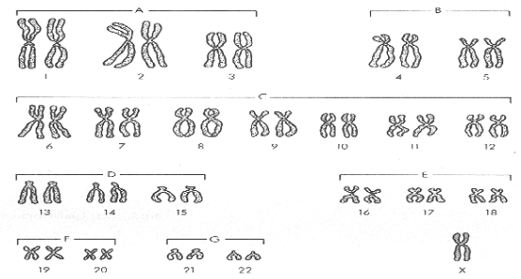 | 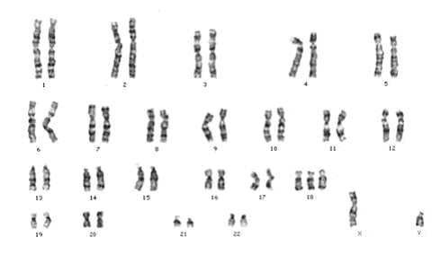 | 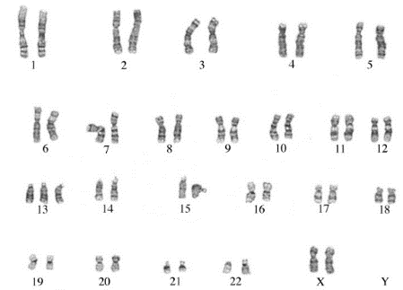
Gender? | Gender? | Gender?
Disorder: Turner Syndrome | Disorder: Edward’s Syndrome | Disorder: Patau Syndrome
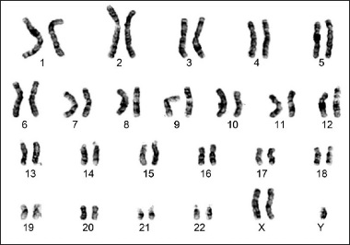 | 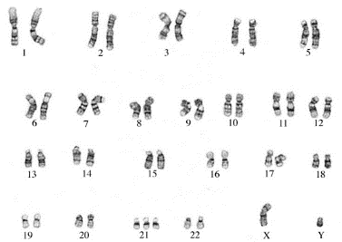 | 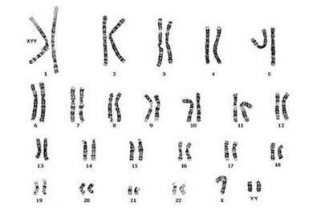
Gender? | Gender? | Gender?
Disorder: Klinefelter’s Syndrome | Disorder: Down Syndrome | Disorder: Jacob Syndrome

3. A chart that shows the family history for one genetic trait is called a ________________ (karyotype or pedigree). The different genders are shown with different shapes. A male is shown with a _____________________ and a female is shown with a _________________. If a person has the trait, their shape will be shaded. Sometimes carriers are half shaded.
4. For the pedigree to the right, the trait is hitchhiker’s thumb which is recessive. Those with a hitchhiker’s thumb therefore are hh. Name the gender and GENOTYPE for each individual in the chart.
Individual | Gender | Genotype  HH, Hh, hh or H?
I-1
I-2
II-2
III-4
III-8
V-1
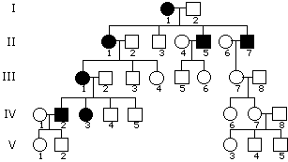

5. For the pedigree charts below, state in the box below whether the trait would be:
- AUTOSOMAL RECESSIVE (if it skips a generation)
- AUTOSOMAL DOMINANT (if two affected parents have an unaffected child)
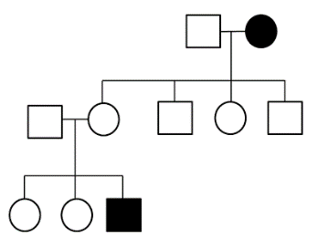 | 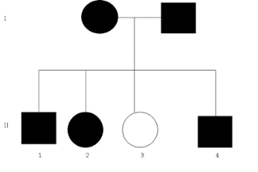 | 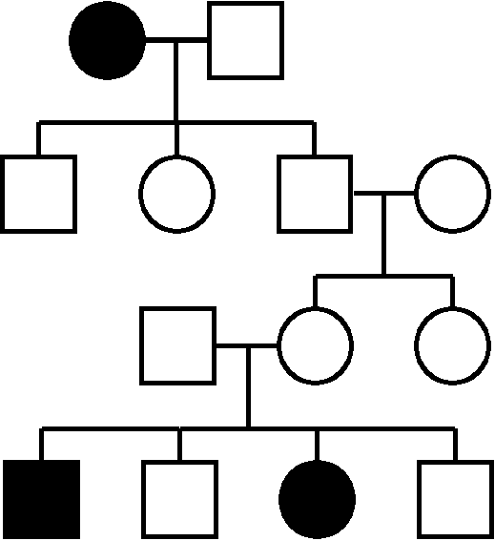 | 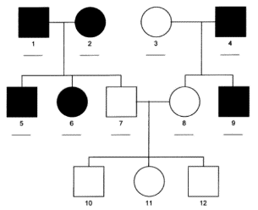 | 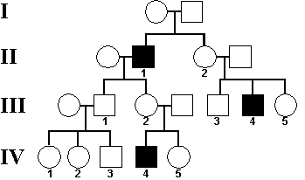
- SEX LINKED RECESSIVE (if more males are affected).

6. For the following disorders, write AR if it is Autosomal Recessive, AD if it is Autosomal Dominant and SR if it is Sex Linked Recessive:
Huntington’s Disease ______ Hemophilia _______
Albinism ______ Color-Blindness _______
Achondroplasia ______ Cystic Fibrosis _______

7. Hemophilia is a sex-linked characteristic. Write the genotypes of each individual based on their description. Use X^{H} for normal blood clotting.
_____________ Beth is a carrier for hemophilia
____________ Dale has hemophilia
_____________There is no family history of hemophilia in Tess’s family
_____________ Avery does not have hemophilia but her Dad does
_____________ Adam does not have hemophilia
_____________ Michelle has hemophilia
8. Trent is color blind. His wife Lindsay is not color blind but her father is color blind. What are the odds of them having a colorblind child?
a) Depends on the gender- their sons will all be color blind, their daughters will not be.
b) None of their children will be colorblind since Lindsay is not a color blind.
c) All of their children will be colorblind.
d) Regardless of gender, there is a 50% chance of their child being colorblind.

9. The following is a pedigree for a family who have been affected by cystic fibrosis. Answer the following questions regarding the pedigree. Use A for the normal allele and a for cystic fibrosis:
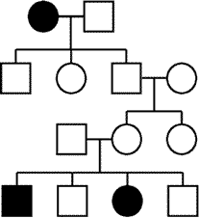
a) What is Carol’s genotype? __________
Josh
Carol

b) Do we know for sure what Josh’s genotype is? _____
Angela
Bryce
Kevin
Marissa
c) What is Hunter’s genotype? __________________

d) Do we know for sure what Julia’s genotype is? _____
Charlotte
Hunter
Julia

e) If Kevin had married a woman with cystic fibrosis, what would have been the chances of their children having cystic fibrosis? _______________________
Chase
Carly
Landon
Ben

10. The following pedigree shows the family pattern for the Sex Linked trait of Color Blindness. Use X^{B} for normal color vision and X^{b} for the colorblindness allele.
Use this Punnett Square for part c of this question
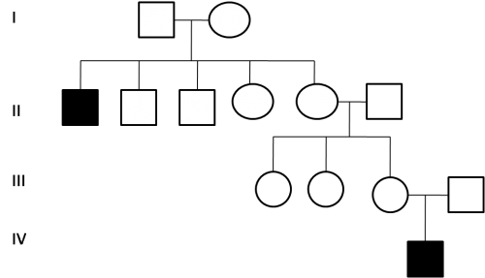

a) Half shade in all individuals that you know are CARRIERS for color blindness

b) What are the GENOTYPES of the two individuals in Generation 1? __ ____ and __ _______

c) The individual shown in Generation IV is the first child born to his parents. They go on to have twins, one boy and one girl. What are the odds the new son is color blind? _________%
What are the odds their daughter is color blind? ________%

11. One allele is not always completely dominant over another. In both Co-Dominance and Incomplete Dominance, there is an additional phenotype for the heterozygote. For the examples below, write whether the description suggests CO-DOMINANCE (CO) or INCOMPLETE DOMINANCE (INC)
________ a) Tabby cats have patches of orange, tan and brown fur
________ b) Jamarea has type AB blood
________ c) A red and blue flower crossed produce purple offspring
________ d) Two medium height plants are crossed and have tall, medium and short offspring
________ e) Jonas has straight hair, Ruby has curly hair and their daughters have wavy hair

12. In roses, red petals and yellow petals are incompletely dominant to each other, with the heterozygote producing orange flowers. A florist wants to create a bouquet of lots of orange roses, with some yellow and red thrown in as well. What two parent flowers should he cross to produce red, orange and yellow roses in the offspring?
Parent one genotype: ___________ Parent one phenotype: _____________
Parent two genotype: ____________ Parent two phenotype: _____________

13. Blood type is an example of Multiple Alleles because there are 3 alleles- I^{A}, I^{B} and i. I^{A} and I^{B} are co-dominant while “i” is recessive. Fill in the chart below, listing the genotypes that give each Blood Type.
GENOTYPE | BLOOD TYPE
 | TYPE A blood
 | TYPE A blood
 | TYPE B blood
 | TYPE B blood
 | TYPE AB blood
 | TYPE O blood

14. Anna has type A blood but her dad had type O blood. Her husband Ryan has type AB blood. What are the genotype and phenotype ratios that represent the blood type possibilities for the future offspring?

GENOTYPE RATIO:

PHENOTYPE RATIO:

15. Which of the following is TRUE about dihybrid crosses:
a) A dihybrid cross can produce 16 possible phenotypes
b) There are four possible genotypes when doing a dihybrid cross
c) When doing a dihybrid cross, four different phenotypes are possible
d) All dihybrid crosses will give a 9:3:3:1 phenotype ratio
16. Write the GENOTYPE for both traits for each person listed below (you should have FOUR letters for each person). The trait ofhaving freckles (A) is dominant to no freckles (a) and having dimples (D) is dominant to not having dimples.
__________ Peter has freckles but his mother did not; he does not have dimples
__________ Rodney does not have freckles but is homozygous dominant for dimples
__________ Alica is a heterozygote for freckles and does not have dimples
__________ Susan has freckles but her daughter does not; she is a hybrid for the dimples trait
__________ Josie does no thave freckles or dimples
__________ Belinda has both freckles and dimples but her dad did not have either

17. Use the chart below to practice foiling. Then count how many different gamete combinations there are for the parent and record in the last row.
 | EeRr | BBHh | aaDd | GgNN | QQbb
F (first)
O (outside)
I (inside)
L (last)
# of DIFFERENT
Gamete combos
.
18. In flowers, Tall height (H) is dominant is over short height. Purple flowers (A) are dominant over white flowers. What would be the PHENOTYPE ratio if you were to cross a purebred tall white plant with a plant that is a hybrid for both height and color?

Alleles: ______________ ________________

Parent 1: _____________ Parent 2: ______________

Possible Gametes Parent 1: Possible Gametes Parent 2:
_________ ___________
_________ __________
_________ __________
__________ ___________
PHENOTYPE RATIO? ___________________________________________

19. In the table below, study the DNA fingerprints and determine in each case which suspect you believe committed the crime:
DNA FINGERPRINT | 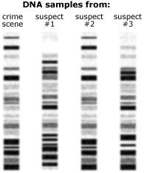 | 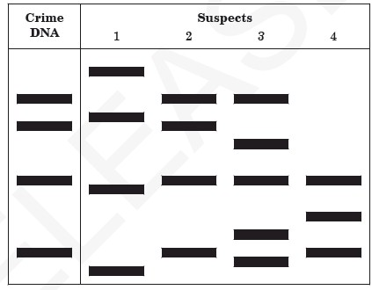 | 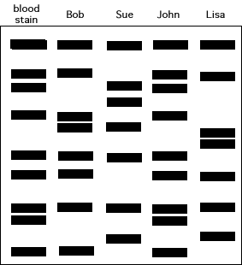 | 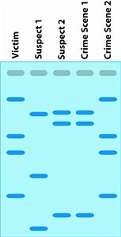
WHO IS GUILTY?

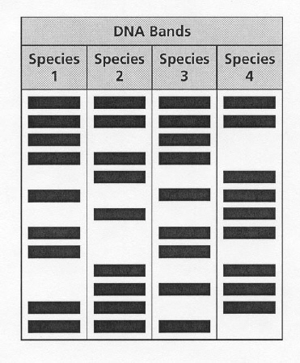
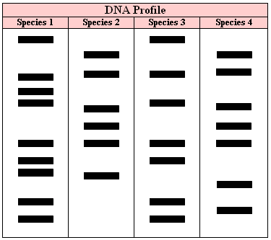
20. Gel Electrophoresis is used to create DNA Fingerprints for four different species in a meta evolutionary analysis. In the two pictures below, state which two species appear most closely related in each case:
MOST CLOSELY
RELATED SPECIES?
____ & _____

MOST CLOSELY
RELATED SPECIES?
_____ & _____

21. Three dogs are used to create the first clone of a pet. An egg cell is taken from a golden retriever and the nucleus is removed from it. Into the egg is placed the nucleus from a cocker spaniel. Electricity is used to stimulate mitotic growth. Once the zygote is several cells big, it is placed into a border collie. When the clone baby is born, it will be what breed of dog?
a) Golden Retriever
b) Cocker Spaniel
c) Border Collie
d) a mixture of all three breeds

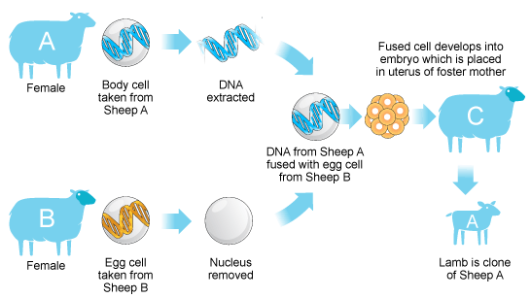
22. Use the picture below to answer the questions to the side of it:
a) Which sheep is the baby lamb a clone of (A, B, C)? _________

b) Which sheep will give birth to the baby lamb (A, B, C)? _________

c) Sheep A has a genetic mutation causing blindness. What are the chances the baby lamb will be blind? _____ %

