Name: ___________________ DOC #:63
ORHS BIOLOGY 2017
ECOLOGICAL SUCCESSION WORKSHEET

1. Succession is best defined at as a ______________ series of changes that occur in an ecosystem over time:
a) random
b) predictable
c) rapid
d) beneficial

2. The first species to colonize an area is called a ______________ species and the final stable state of succession is called the _________ community.

3. Primary succession in the first series of growth on that land and typically begins on a ___________ surface. Secondary succession is re-growth following destruction to an ecosystem and begins on ________ which is still present from previous life.

3. In primary succession, an example of a common pioneer species would be _____________, while in secondary sucession the pioneer species is more likely to be ______________
a) lichens, grasses
b) lichens, moss
c) grasses, lichens
d) grasses, tall trees

4. Starting on bare rock, what is the usual order of primary succession in a community?
a) lichens shrubs grasses trees
b) grasses shrubs lichens trees
c) lichens grasses shrubs trees
d) shrubs grasses lichens trees

5. Which statement concerning the climax stage of ecological succession is correct?
a) It is the first community to inhabit an area
b) It consists only of plants
c) It persists until the environment changes
d) It changes rapidly

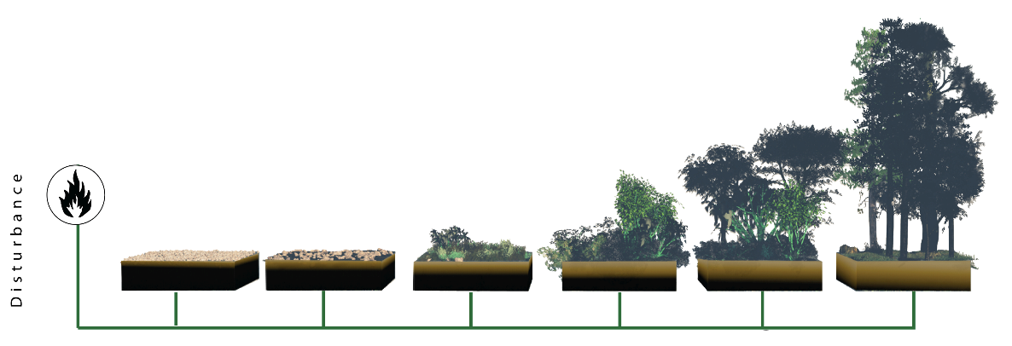
6. The picture below uses a fire symbol to represent a disturbance. Therefore it is representing ___________ succession. In the boxes label PIONEER SPECIES, INTERMEDIATE SPECIES and CLIMAX COMMUNITY

7. The pictures below represent four stages of succession, in a random order. Indicate the order the pictures should be in to accurately represent ecological succession:
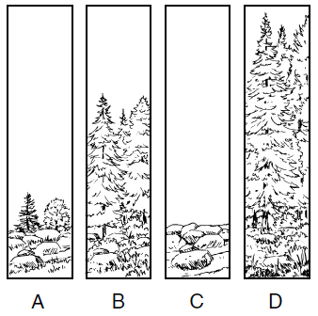

The letters should be in the order of:

______ _______ _______ _______

8. The picture below is representing ______________ succession (primary or secondary). How did you know this? _____________________________________________________________________
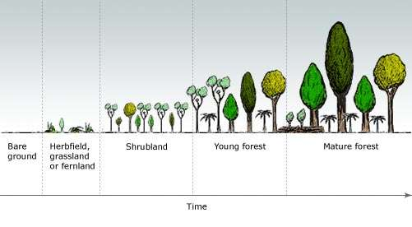

9. The picture below is representing ______________ succession (primary or secondary). How did you know this? _____________________________________________________________________
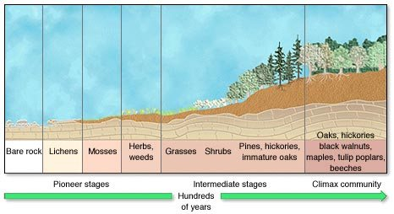

10. Animal species also follow patterns of succession. The type and abundance of animal life found in the ecosystem at any given time is most closely caused by:
a) the quality of the soil
b) availability of sunlight
c) extent of damage caused by fire
d) what plant life is predominant at that stage

