Word Bank: Evolution, Speciation, Species, Adaptation, Mutation
A change in the DNA sequence.
An inherited trait that is selected for over time because it allows organisms to better survive in their environment.
A group of similar organisms that can breed and produce fertile offspring.
The formation of new species.
A change in a species over time; process of biological change by which descendants come to differ from their ancestors.

Background Information: Charles Darwin, while on his research adventure around the world during the 1830’s, noticed that birds of the Galapagos Islands had similar characteristics to birds on the mainland of South America, but the shapes and sizes of their beaks were very different. He assumed that the birds were all different species, but discovered upon his return to England that they were actually all finches.

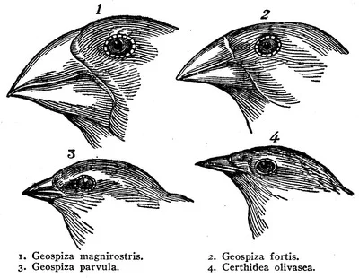
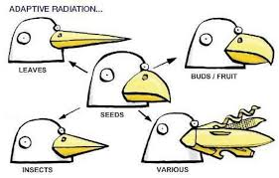
The differences in the beaks caused Darwin to think about how variation in the size and shape of a bird’s beak can affect whether or not that bird will survive in the environment. Variation is often caused by a mutation. If a beak mutation allows a bird to become better fit for the environment, then the bird will be able to obtain more food, potentially surviving longer, and therefore producing more offspring that carry the mutated gene. This mutation will be passed onto future generations, increasing the allele frequency of the “new” beak in the population, and this variation becomes an adaptation. Eventually, the birds with the “new” beak adaptation will no longer breed with the “original” beak birds, thus creating a separate species.
Looking at a bird’s beak can help you determine the type of food it eats.

EXAMPLE: Birds in an area have a short, thick beak which is good for cracking and opening seeds. A mutation in a particular bird produces offspring with beaks that are slightly longer and thinner, allowing the birds with the mutated beaks to retrieve seeds from cracks in the ground’s surface that birds with short, thick beaks cannot reach. An earthquake causes the landscape to change, adding several thin cracks that the seeds fall into. The birds with the shorter, thicker beaks cannot reach most of the seeds. The birds with the longer, thinner beaks have more access to food, which leads to a greater rate of survival. They will produce more offspring than the birds with short, thick beaks, causing the original population to evolve.
Purpose: This investigation is designed to help you understand how variation within a species leads to speciation.

Materials: Plastic spoon, plastic fork, tweezers, clothespin, tongue depressor, small container (per bird)

Procedure:
- Choose a utensil to use as a “beak.”
- Place yourself around the “Island” area, with the “food” spread evenly throughout.
- When the teacher calls the time, all students will use their “beak” to gather food for 30 seconds. Food can be picked up with the beak only one piece at a time and placed in a container “nest.”
- Use the data table provided to record the number of pieces of food gathered by each beak.
- Return the food from the container back to the felt square.
- Taking your utensil with you and rotate to the next station upon teacher instruction.
- Repeat steps 2-6.
 |  | # pieces of food eaten
 | Beak Type | Rice Island Maggots | Raisin Island  Grubs | Marble Island Snails
1 | Spoon
2 | Fork
3 | Tweezers
4 | Clothespins
5 | Tongue Depressor
Which beak is most fit for the available food source?

- Repeat steps 1-3 for the raisin-grubs and then for the marble snails. Then record the results of the numbers eaten to the data table.
- Compare your results with the rest of the class.

Discussion:
- How does variation (caused by a mutation) in beak size and shape lead to speciation in the birds? ______________________________________________________________________________________________________________________________________________
_______________________________________________________________________

- What information do you need to fully determine which bird is the most fit for the available food?
_______________________________________________________________________
- Which beak is most fit for the Rice Island? Why? _________________________________
_______________________________________________________________________
- If instead of using a white spoon for this experiment, you were given a red spoon, what kind of impact would that have on the number of pieces of food you were able to collect? Explain.
______________________________________________________________________________________________________________________________________________

MOTH HUNT
Industrial Melanism is a term used to describe the adaptation of a population in response to pollution. One example of rapid industrial melanism occurred in population of peppered moths in the area of Manchester, England from 1845 to 1890. Before the Industrial Revolution, the trunks of the trees in the forest around Manchester were light grayish-green due to the presence of lichens. Most of the peppered moths in the area were light colored with dark spots. As the industrial revolution progressed, the tree trunks became covered with soot and turned dark. Over a period of 45 years, the dark variety of the peppered moth became more common.
Procedure:
You will be given a bag of 10 “moths.” Each person in your group will have a different color or pattern of moths. One person will be the designated “Moth Hunter.”

      - Each person will spread the moths from their bag over the background area on the table, while the “Moth Hunter” isn’t looking. The background represents the environment that the moth lives in.
      - The Moth Hunter will have 10 seconds to pick up as many moths as possible.
      - Count the number of each color of moth collected and record on the table below.
      - Gather your moths and place them back in the bag and take them with you as you rotate to the next table, when your teacher instructs you to do so.
      - Repeat steps 1-4.
 | NUMBER OF SURVIVORS
COLOR OF MOTH | ISLAND ONE  White | ISLAND TWO  Black | ISLAND THREE  Black & White
White
Black
Black & White
Off White
Red

Discussion:
1. Which color of moth had the greatest number of survivors in:
The white background environment?______________
The black background environment?______________
The black & white? ____________
Why was this? ______________________________________________________________
2. Which color of moth consistently had the lowest number of survivors?_____________________
Explain the reason for this: ____________________________________________________
3. Using the information from the questions above, describe the importance of color in avoiding predation: ___________________________________________________________________________
___________________________________________________________________________
4. How do environmental changes affect individual organisms? _____________________________
___________________________________________________________________________
5. How does natural selection cause populations to change? _______________________________
___________________________________________________________________________
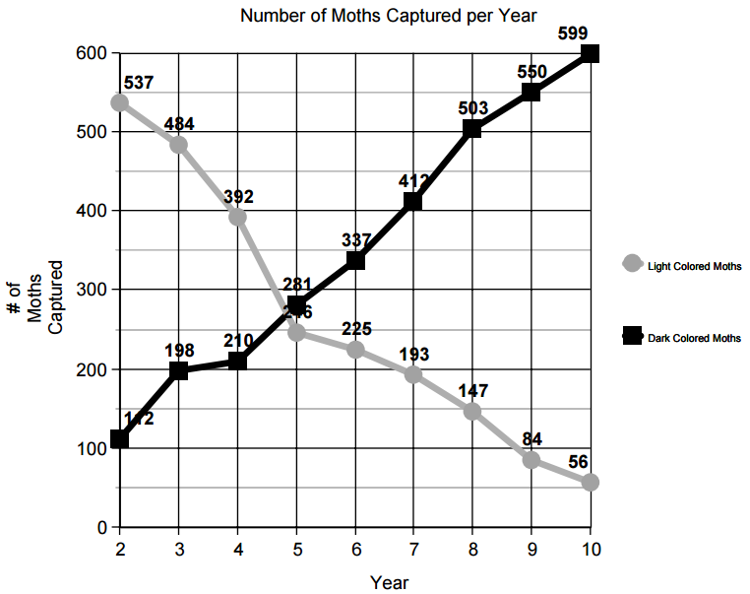
___________________________________________________________________________

6. Analyze the graph above. In your own words, explain what the graph shows: __________________
____________________________________________________________________________
7. Describe a situation where this type of selection might occur: ____________________________
____________________________________________________________________________

