Evidence of Evolution Worksheet -Level
DOC # 73
NAME: ____________________________________

Background
When Charles Darwin first proposed the idea that all new species descend from an ancestor, he performed an exhaustive amount of research to provide as much evidence as possible. Today, the major pieces of evidence for this theory can be broken down into the fossil record, embryology, comparative anatomy, and molecular biology.
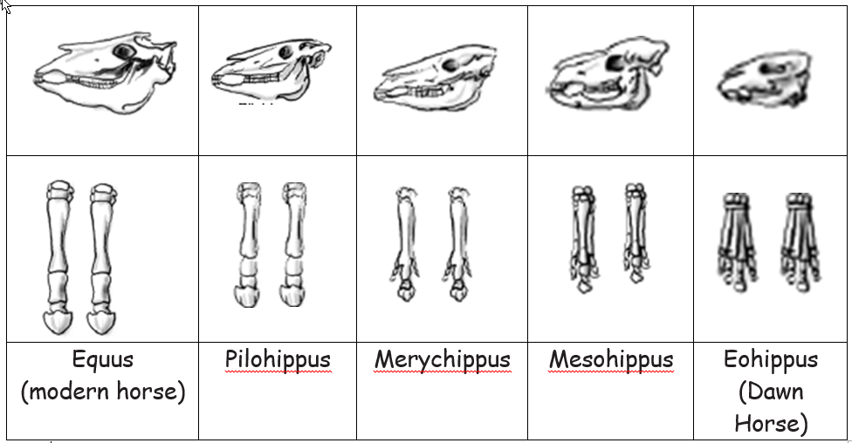
Fossils:

1. Give two similarities between each of the skulls that might lead to the conclusion that these are all related species.

2. What is the biggest change in skull anatomy that occurred from the dawn horse to the modern horse?

3. What is the biggest change in leg anatomy that occurred from the dawn horse to the modern horse?

Embryology
Organisms that are closely related may also have physical similarities before they are even born! Take a look at the six different embryos in PICTURE A:

Hypothesize which embryo is from each of the following organisms:
Species | Embryo (LETTER)
Human
Chicken
Rabbit
Tortoise
Salamander
Fish

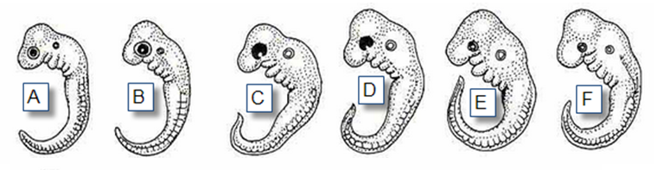

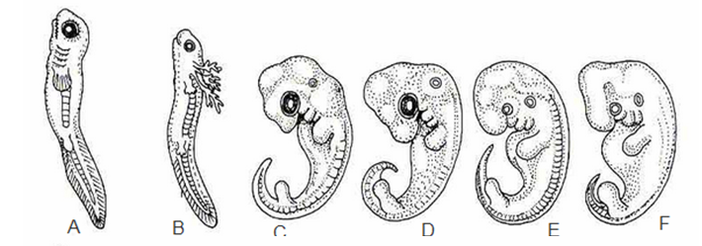
Now look at PICTURE B. These are older, more developed embryos from the same organisms. Again hypothesize which embryo came from each organism. Your answers may change now!
Species | Embryo
Human
Chicken
Rabbit
Tortoise
Salamander
Fish

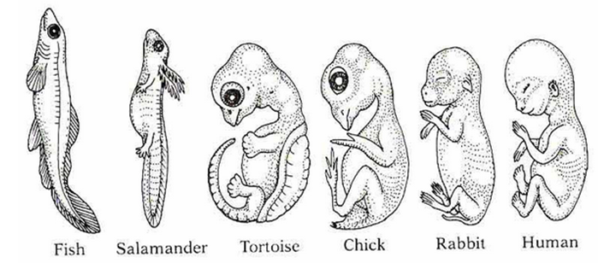
Once you have made your hypotheses, you can ask your teacher for PICTURE C. This shows the embryos at their most advanced stage, shortly before birth and labels them. Using that picture, describe how the embryos changed for each of these organisms from their earliest to latest stages.

Species | Anatomical Changes From Early to Late Stages
Human
Chicken
Rabbit
Tortoise
Salamander
Fish

1. Look again at the six embryos in their earliest stages. Describe the patterns you see. What physical similarities exist between each of the embryos?

2. Does this suggest an evolutionary relationship? Explain how these embryos can be used as evidence of a common ancestor between each of these six organisms.

Comparative Anatomy
Part 1: In the picture below, there are images of the skeletal structure of the front limbs of 6 animals: human, crocodile, whale, cat, bird, and bat. Each animal has a similar set of bones. Use that picture to compare the skeletal structure of each limb to the human arm. Relate the differences you see in form to the differences in function.

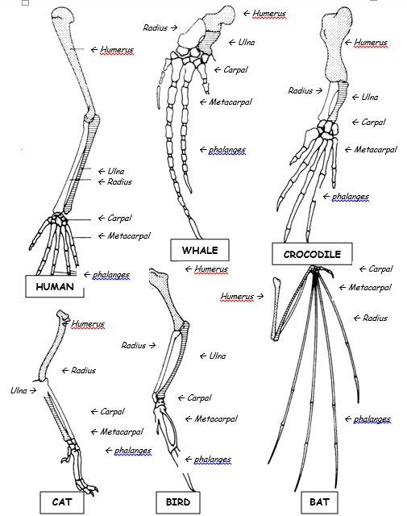

Animal | 1 DIFFERENCE to Human Arm in Form | 1 DIFFERENCE to Human Arm in Function
Whale | Whale has a much shorter and thicker humerus, radius, and ulna. Much longer metacarpals. Thumb has been shortened to a stub. | The whale fin needs to be longer to help in movement through water. Thumbs are not necessary as the fins are not used for grasping.
Cat
Bat

Are the structures on the previous page examples of homologous or analogous structures? _______________________

Part 2: In the picture below, you can compare the anatomy of the butterfly and bird wing. Use that picture to answer the questions:
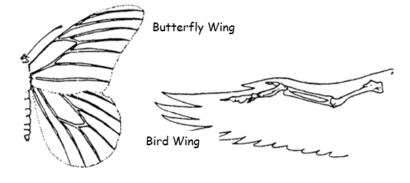

1. What is the function of each of these structures?

2. How are they different in form? Give specific differences.

3. Are these examples of homologous or analogous structures? ______________________________

Part 3: In the picture below, you can compare the overall body structure of the cave fish and the minnow. Use that picture to answer the questions:
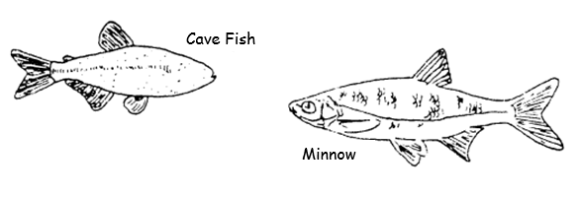

1. What is the biggest, most obvious difference between the body structure of these two fish?

2. Assume the two fish came from the same original ancestor. Why might the cave fish have evolved without eyesight?

Part 4 Below are some vestigial structures found in humans. For each, with your group hypothesize what its function may have been.
Structure | Possible function?
Wisdom teeth
Appendix
Muscles for moving the ear
Body hair

How are vestigial structures an example of evidence of evolution?

Molecular Biology
Cytochrome c is a protein found in mitochondria. It is used in the study of evolutionary relationships because most animals have this protein. Cytochrome c is made of 104 amino acids joined together. Below is a list of the amino acids in part of a cytochrome protein molecule for 9 different animals. Any sequences exactly the same for all animals have been skipped.

For each non-human animal, count how any amino acids that are different than the human sequence. When you finish, record how many differences you found in the results table.
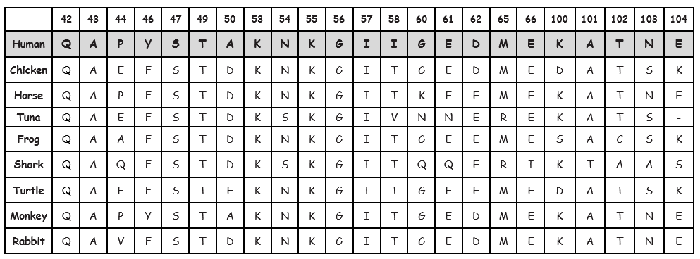

RESULTS TABLE:
Animal | Number of Amino Acid Differences Compared to Human Cytochrome C | Animal | Number of Amino Acid Differences Compared to Human Cytochrome C
Horse |  | Shark
Chicken |  | Turtle
Tuna |  | Monkey
Frog |  | Rabbit

1. Based on the Cytochrome C data, which organism is most closely related to humans?

2. Do any of the organisms have the same number of differences from human Cytochrome C? In situations like this, how would you decide which is more closely related to humans?

EVIDENCE FOR EVOLUTION CONCLUSION
1. Charles Darwin published his book On the Origin of Species in 1859. Of the different types of evidence that you have examined, which do you think he relied upon the most, and why?

2. Given the amount of research and evidence available on evolution, why is it classified as a theory?

