**Name _______________________________Date _____________________ Doc # 81**

**Evolution Level Test Review**

1. What type of organism did Darwin observe on the Galapagos Islands? __________________
2. What differences did Darwin observe about the finches? _______________________________________________________________________
3. Define the term “fittest” according to Darwin. _______________________________________________________________________ _______________________________________________________________________
4. 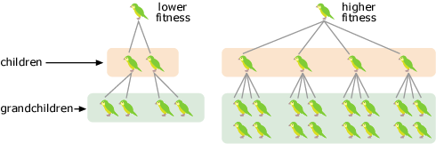Fitness is a measure of reproductive success. So the fittest individual is really the one who has the greatest number of ________________ ________________.
5. Define Natural Selection: _______________________________________________________________________ ______________________________________________________________________________________________________________________________________________
6. Define Artificial Selection (Selective Breeding): _______________________________________________________________________

_________________________________________________________________________

1. Define Evolution. __________________________________________________________
2. An Adaptation is __________________________________________________________. They can be ___________ (something on your body) or _____________ (something you do).
3. What are vestigial structures? Give two examples. _______________________________________________________________________ _______________________________________________________________________
4. What is the difference between a homologous and an analogous structure.? ______________________________________________________________________________________________________________________________________________
5. 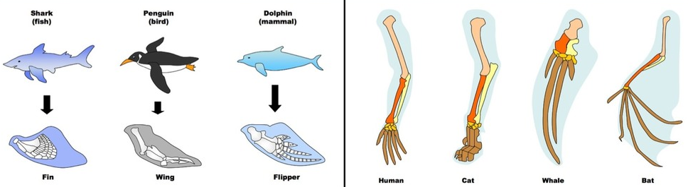Label the following pictures as either Homologous or Analogous.

**_____________________________**

**_____________________________**

1. Define Decent with Modification: _______________________________________________________________________ _______________________________________________________________________
2. What does it mean to have a common ancestor? _______________________________________________________________________
3. 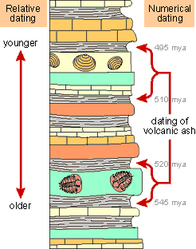What is the fossil record? ____________________________________________________
4. Fossils are _________ of organisms that lived in the past. Fossils in

___________ layers of rock are more primitive than fossils in the

upper (newer) layers of rock.

1. How does the fossil record support Evolution? ______________________________________________________________________________________________________________________________________________
2. Examples of fossils are _________, _________, __________, ______________________, ___________.
3. What is the difference between relative dating of fossils and absolute dating of fossils? _______________________________________________________________________

________________________________________________________________________

1. Define Speciation. _____________________________________________________________________
2. Explain how rats adapted to no longer be affected by the rat poison. _______________________________________________________________________ ______________________________________________________________________________________________________________________________________________
3. What is a gene pool? _______________________________________________________________________
4. All adaptations begin as a genetic ______________. These mutations will become more frequent in the population only if they provide a survival or reproductive advantage.
5. How does the similar banding patterns between the Scarlet King Snake and the Eastern Coral snake provide an adaptation for the King Snake? ___________________________________

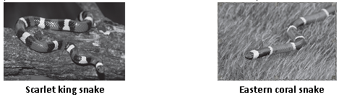 ________________________________________________________________________

1. When allele frequencies of a population remain the same it is called: _______________ __________________.
2. If allele frequencies do not stay the same but change, this leads to _______________ (the opposite of equilibrium).
3. In order to maintain the allele frequency (genetic equilibrium) in a species the following must occur: (Hardy-Weinburg Principle)
   1. ____________________________________
   2. ____________________________________
   3. ____________________________________
   4. ____________________________________
   5. ____________________________________
4. Describe the process of Genetic Drift: _______________________________________________________________________ _______________________________________________________________________
5. Genetic drift can be caused by two processes. Explain each:

Bottleneck Effect ___________________________________________________________

_________________________________________________________________________

Founder Effect _____________________________________________________________

_________________________________________________________________________

1. 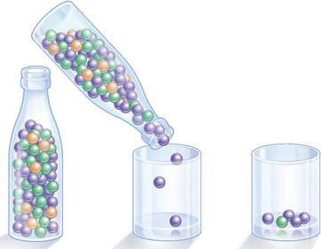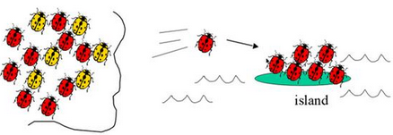Label each picture as representing either the Bottleneck Effect or the Founder Effect

**_____________________________**

**_____________________________**

1. When a small population is geographically isolated (genetic drift), is this population likely to show an increase **or** decrease in genetic variation/diversity? __________________________
2. When migration occurs and leads to gene flow, is this population likely to show an increase **or** decrease in genetic variation/diversity? ________________________________
3. How is Antibiotic Resistance an example of Natural Selection? Explain what is happening to the bacteria in each picture

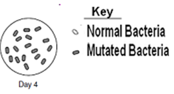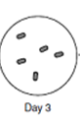

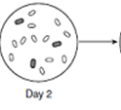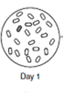

_______________ ________________ _______________ __________________

_______________ ________________ _______________ __________________

______________ ________________ _______________ __________________

_______________ ________________ _______________ __________________

1. Organisms that are more closely related would also share more similarities in their DNA and the ______________ that are coded for by the DNA.

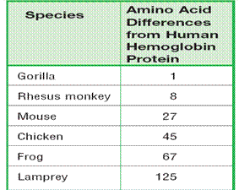

According to the picture, which species would be most closely related to humans? _____________________

1. Many scientists have contributed to our understanding of genetics. Name the scientist that goes with each accomplishment:

__________________ Proposed that the Earth is millions not thousands of years old.

**__________________**Predicted that the human population will grow faster than the space and food supplies needed to sustain it.

__________________Provided the first flawed explanation of evolution saying that through the use or disuse of organs, organisms acquired or lost certain traits in their lifetime.

**__________________** “The Father of Evolution” published a book entitled “On the Origin of Species” in which he described evolution, natural selection, and fitness.

1. List **FIVE** evidences of evolution:
2. __________________________________________________________________
3. __________________________________________________________________
4. __________________________________________________________________
5. __________________________________________________________________
6. __________________________________________________________________
7. For the following scenarios indicate if it is an example of Genetic Drift or Gene Flow.
   1. One of the original Amish settlers who founded a new area for them had a rare, genetic disorder which causes short limbs and extra digits. Now, many within the population show this trait.___________________
   2. Maria Concepcion Soto settled in the northern area of Venezuela. She suffered from a rare genetic disorder called Huntington’s Disease. As a result, the now 20,000 individuals who live there also have a high risk of Huntington’s Disease. _______________
   3. A Ridgenose Rattlesnake leaves the Huachuca Mountains and now breeds on the Santa Rita Mountains with another established population. ___________________