Name: ________________________________ Date: ________ Doc #: 99

Flower Dissection: Flower Parts, Functions and Pollination

Diagram of a flower:
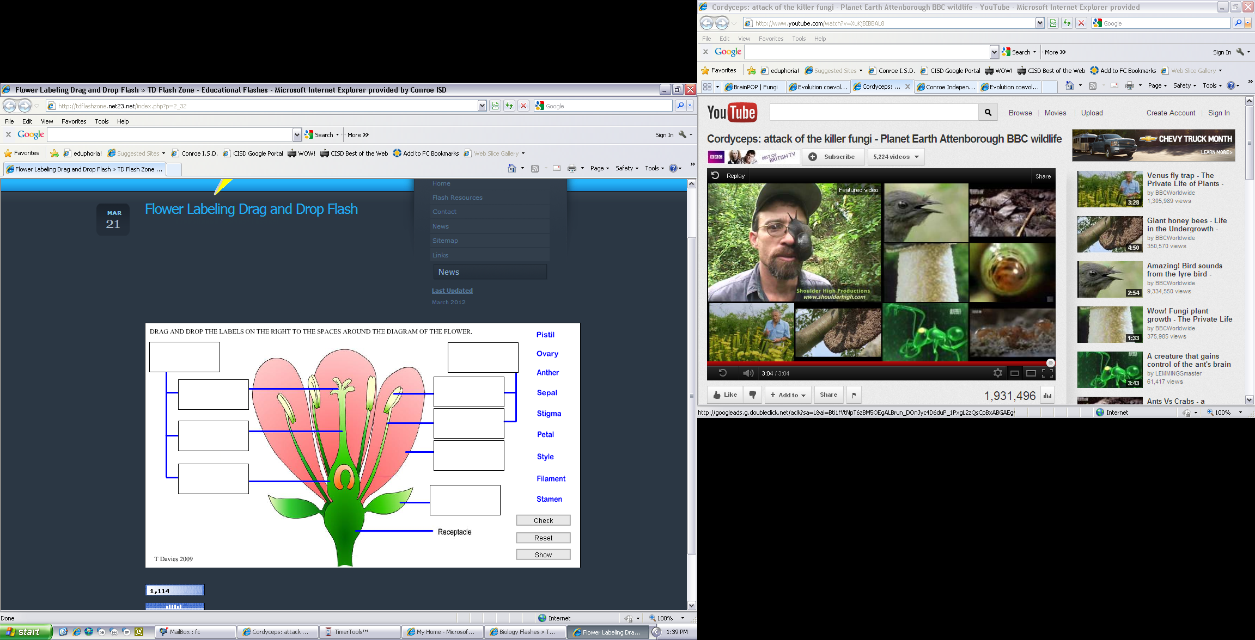

Petal: Petals are used to ___________ insects into the flower, they may have _______________ on them and be __________________.
Sepal: Sepals ________________ the flower whilst the flower is developing from a __________.

The filament and the Anthers are collectively known as the _______________ or the _______ parts of the plant. | Anther: The Anthers contain _____________ sacs. The sacs release pollen on to the outside of the anthers.
 | Filament: This is the stalk of the Anther.
The stigma, style, ovary, and ovule are often known collectively as the _____________(or ________) or ______________ parts of the flower. | Stigma: Is covered in a ________ substance that the _______________grains will adhere to.
 | Style: The style raises the stigma away from the ovary to __________ the likelihood of pollen ______________________. It varies in length.
 | Ovary: This ____________ the ovule and once fertilization has taken place it will become the ______________.
 | Ovule: The Ovule is like the ______, once fertilization has taken place will become the ___________.

Types of pollination

_________________ pollination: On animals, the pollen is picked up on a part of the________________ and is carried to another flower. Bright flowers and sweet nectar attract animals.

________________ pollination: the pollen is carried away and moves by ___________. Only a _______________fraction of pollen reaches another flower of that species and so it is able to produce a seed.

What is pollination?

_____________ produced on the ___________ must move to another flower, and land on a part called the _____________. Stigma captures pollen on sticky secretions and is transported _________ the _____________ in pollen tubes to the ovary where the _____________is fertilized. The fertilized egg develops into a seed and the whole _______________ matures into a __________________.

