Name: ________________________________________ DOC #: 38

PROTEIN SYNTHESIS
LEVEL TEST REVIEW

1. For each statement, write whether it describes DNA, RNA or BOTH
a) Has the base URACIL _________
b) Has a RIBOSE sugar _________
c) Is DOUBLE STRANDED _________
d) Has PHOSPHATE GROUPS _________
d) Has a DEOXYRIBOSE SUGAR _________
e) Has the base ADENINE _________
f) Has the base THYMINE _________
g) Is SINGLE STRANDED _________

2. Draw lines to match each picture to the type of RNA it is and a description of its role:
PICTURE TYPES ROLES
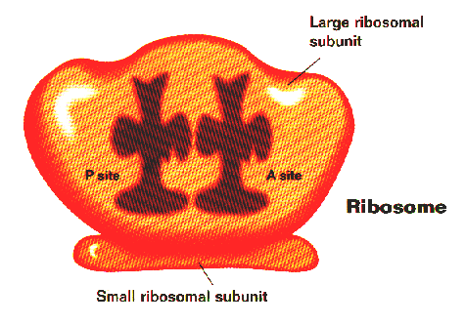
carries amino acids to ribosome to construct the protein

mRNA

carries the DNA code for the protein to the ribosome
tRNA

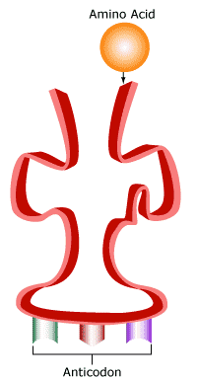
Molecular component of the ribosome
rRNA

3. Protein Synthesis occurs in two main steps:
STEP 1 is _______________ (transcription or translation?) and its end goal/product is ____________ (mRNA or Proteins)
STEP 2 is _______________ (transcription or translation?) and its end goal/product is ____________ (mRNA or Proteins)

4. The reason that DNA cannot leave the nucleus during transcription is:
a) it could get lost
b) the nuclear membrane is sealed shut and nothing can leave
c) it is too large to fit through the pores of the nuclear membrane
d) the cytoplasm is allergic to thymine and you would die

5. Your body needs to make proteins. The instructions for the protein come from:
a) the number of phosphates in the mRNA
b) the anti-codon on the tRNA joining with the codon
c) the order of the nucleotides found in the rRNA
d) the sequence of the bases found in the DNA
6. Similar to DNA Replication, Transcription relies on the action of four enzymes. Complete the table describing their role in Transcription:
ENZYME | FUNCTION | NICKNAME
 | Breaks the Hydrogen bonds in the original strand of DNA
 | Brings in the matching RNA bases to make mRNA
 | Seals the original DNA helix make together once the mRNA has left
 | Winds the original DNA molecules back into a double helix
WORD BANK:
Enzyme Choices are: GYRASE, LIGASE, HELICASE, DNA POLYMERASE
Nickname Choices are: RHONDA THE DATE MATCHMAKER, GINA THE GYMNAST, LISA THE LOVE SPELL, HELEN THE HOMEWRECKER

7. Practice TRANSCRIPTION by writing the mRNA strand that would be complementary to each DNA strand:
DNA | ATG | TCC | CGA | GGG | GCA | CAA | GAG | TAT | TCG | AAA | TCC | CTT | GAT
mRNA

8. Which statement correctly describes the relationship of codons and anti-codons:
a) The anti-codon on the mRNA is complementary to the codon on the tRNA
b) The anti-codon on the mRNA is anti-complementary to the codon on the tRNA
c) The anti-codon on the tRNA is complementary to the codon on the mRNA
d) The anti-codon on the tRNA is complementary to the codon on the DNA

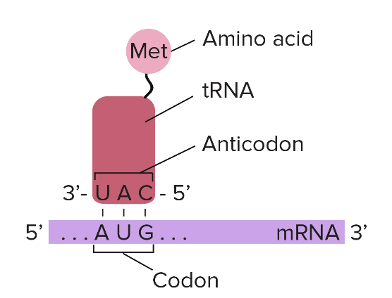
9. Label the following picture with the following labels:

CODON
ANTI-CODON

tRNA
mRNA

AMINO ACID

10. Every THREE nucleotide base pairs makes up ONE codon. Every ONE codon codes for ONE amino acid. Using that statement, complete each statement below with the appropriate number:
- In order to make 5 AMINO ACIDS, you would need ___________ BASES
- If you had 18 BASES, you would have ___________ CODONS
- In order to make 4 AMINO ACIDS, you need to have _________ CODONS
- In order to make 7 AMINO ACIDS, you need to have _________ BASES
- If you had 16 CODONS, you could make ____________ AMINO ACIDS
- If you had 21 BASES, you could make ___________ AMINO ACIDS
11. For the chart below, for each picture, state whether the process it is TRANSCRIPTION, TRANSLATION or REPLICATION. Name the NUCLEIC ACID being pointed at. State WHERE IT OCCURS. State WHAT IS BEING MADE.
PICTURE | PROCESS?  TRANSCRIPTION  REPLICATION  TRANSLATION | WHERE?  NUCLEUS  RIBOSOME | BEING MADE?  DNA  mRNA  PROTEIN
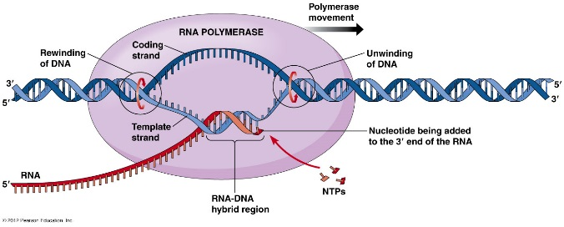

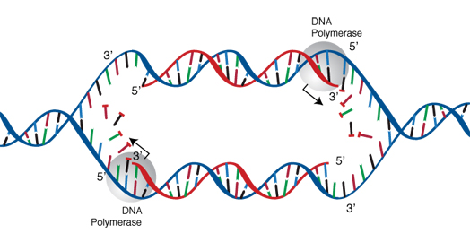
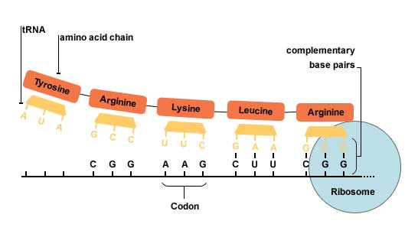

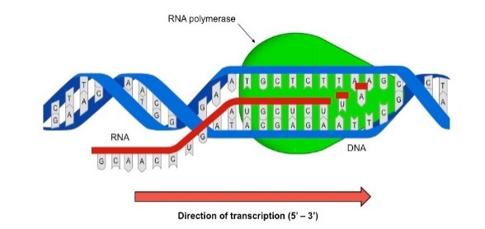

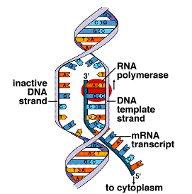

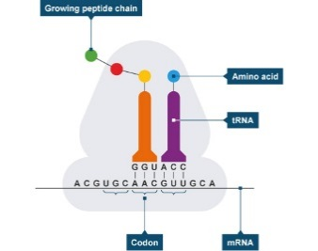
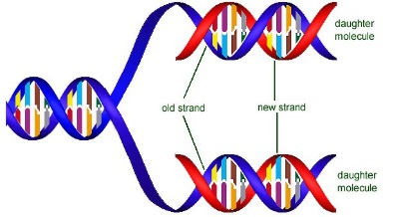

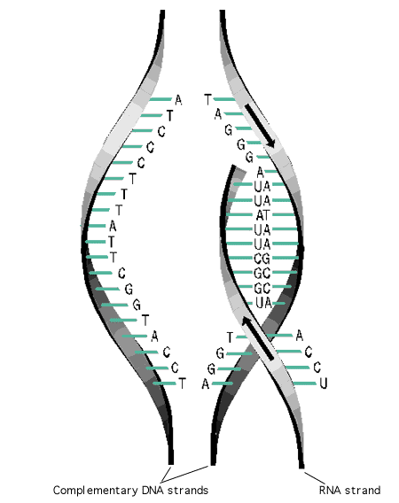

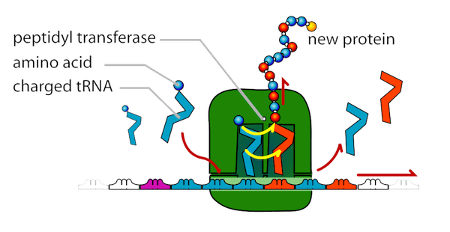

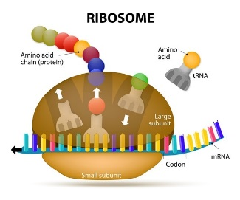

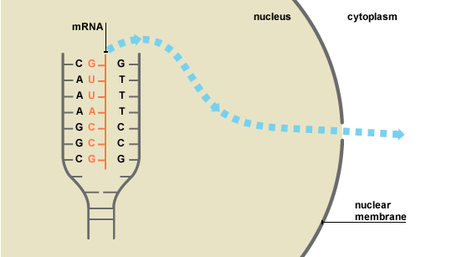

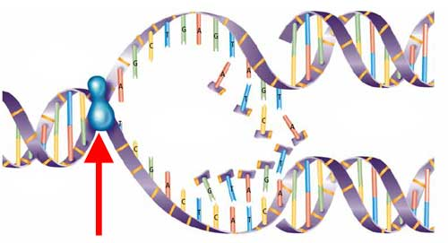

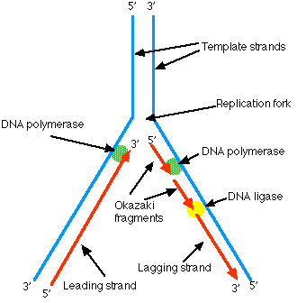

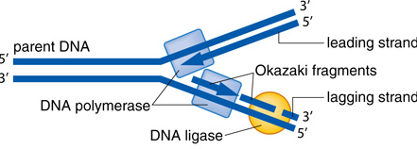

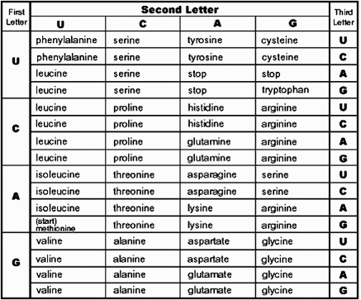
12. Use the codon chart to answer the following statements:
a) for the DNA triplet CAA, the amino acid would be
______________
b) if the amino acid were tryptophan, the CODON is
__________
c) for the mRNA codon GUA, the amino acid would be
_______________
d) three mRNA codons that all code for a STOP codon
are ________, __________ and ________
e) if the amino acid is methionine, the DNA triplet
would have been ____________

13. For each CODON, write the anti-codon that you would find on a tRNA travelling to that codon
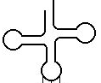

ANTI-
CODON

AUA
GAA
UCC
GAU
CAG
CODON

14. tRNA molecules will continue bring over amino acids until:
a) it has added all 20 different amino acids
b) it reaches a mutation
c) it reaches a STOP codon
d) the cell runs out of tRNA

15. Another name for the growing protein is a:
a) polypeptide
b) carbohydrate
c) pRNA
d) nucleic acid

16. There are 64 different possible codons but only 20 different amino acids. This means that-
a) most of the codons do not code for anything and are useless
b) we need to eat a lot of protein to try and eat the other amino acids
c) several different codons can code for the same amino acid
d) one codon can code for several different amino acids

17. A gene is:
a) all of your DNA found on your chromosomes
b) 3 nucleotides bases that will code for one amino acid
c) the DNA bases found on one single chromosome in a cell in your body
d) the DNA bases that together code for making one protein

18. For each of the following mutations, CIRCLE where the mutation is, and state whether the mutation is a FRAMESHIFT, INVERSION or POINT MUTATION:

ORIGINAL ACCTGACGT
MUTATION ACTGACGT Type of Mutation: ____________________

ORIGINAL GCTACGTTC
MUTATION GCTTGCATC Type of Mutation: ____________________

ORIGINAL CAGATTGGC
MUTATION CAGAATGGC Type of Mutation: ____________________

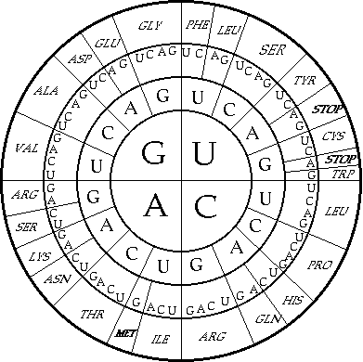
19. For each of the point mutations below, use the codon wheel to determine the ORIGINAL amino acid, the MUTATION amino acid and then decide whether the impact on the protein will be NONE, SMALL or LARGE
MUTATION | ORIGINAL amino acid | MUTATION amino acid | IMPACT? (none, small or large)
UCA UUA
UCA UCC
UCA UAA

20. Select TRUE or FALSE for each of the following statements:
TRUE or FALSE Mutations will only affect offspring if they occur in a gamete
TRUE or FALSE A liver cell would only have the DNA needed for liver function in its nucleus
TRUE or FALSE Point Mutations never have an impact on the protein
TRUE or FALSE Every cell will express all of the genes in its DNA
TRUE or FALSE Mutations can impact individual genes or whole chromosomes
TRUE or FALSE Frameshift mutations generally have a smaller impact than point mutations

21. Label the following picture and complete the paragraph with the words:
GENE, PROTEIN, NUCLEUS, CHROMOSOMES, CELL
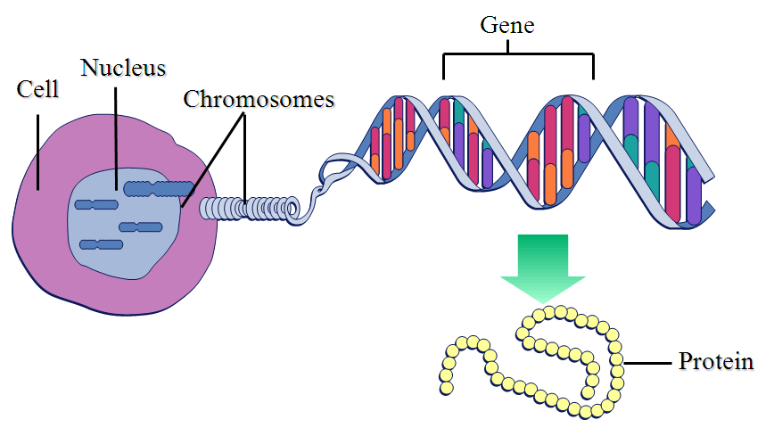
A ______________ is a sequence of DNA nucleotides that code for the making of one _____________. DNA is coiled on ________________ in the _____________ of every ____________ in our body.

