ORHS BIOLOGY Protein Synthesis VOCABULARY
Name: ___________________________ DOC #: V-5

RNA (229) | MESSENGER RNA (230) | TRANSFER RNA (230) | RIBOSOMAL RNA (230)
Definition: | Definition: | Definition: | Definition:
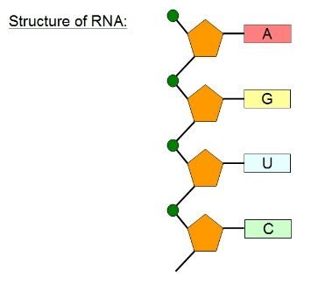 | 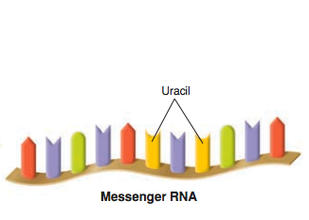 | 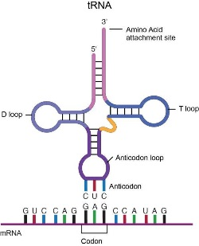 | 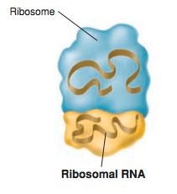
TRANSCRIPTION (230) | URACIL | RIBOSOME (76) | RIBOSE
Definition: | In RNA, the base thymine is replaced with the base URACIL. Uracil will bond with Adenine in RNA. | Definition: | The sugar that makes up RNA nucleotides (instead of Deoxyribose in DNA)
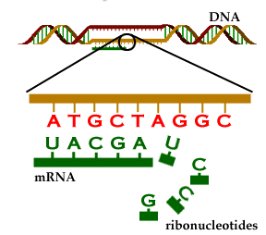 | 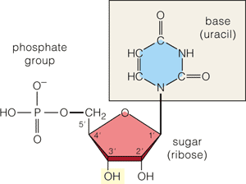 | 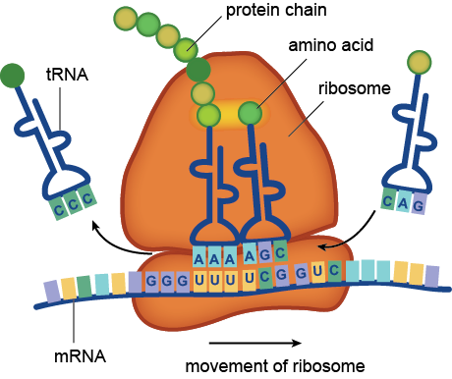 | 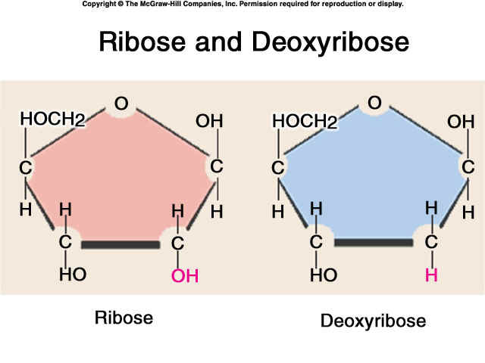
AMINO ACID (49) | PEPTIDE BOND | PROTEIN (49) | CODON (233)
Definition: | The bond formed between two amino acids when making a polypeptide or protein | Definition: | Definition:
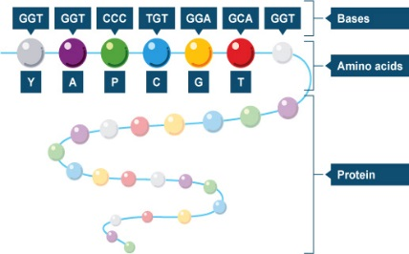 | 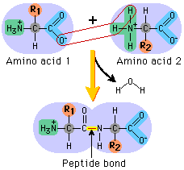 | 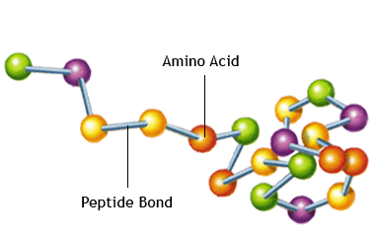  PROTEIN | 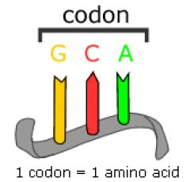
TRANSLATION (233) | ANTI-CODON (235) | MUTATION (244) | POINT MUTATION (244)
Definition: | Definition: | Definition: | Definition:
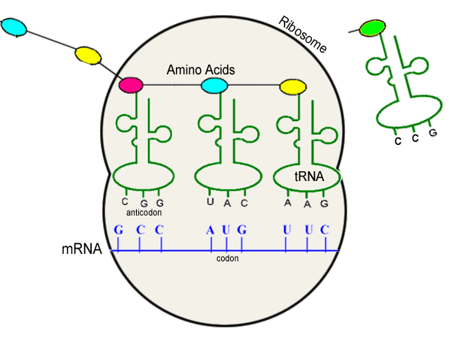 | 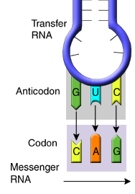 | 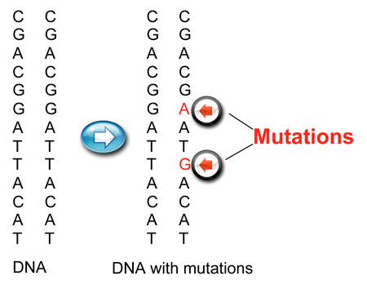 | Normal:  THE CAT RAN FAR  Mutation:  THE RAT RAN FAR
SILENT MUTATION | INSERTION MUTATION | DELETION MUTATION | FRAMESHIFT MUTATION (244)
A point mutation that changes a single DNA base without changing the amino acid coded for- the mutation has no impact on the organism | A type of frameshift mutation where one or more nucleotides are ADDED, disrupting all amino acids after the mutation | A type of frameshift mutation where one or more nucleotides are REMOVED, disrupting all amino acids after the mutation | Definition:
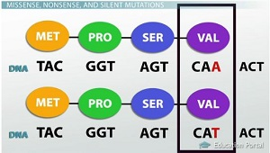 | Normal:  THE CAT RAN FAR  Mutation:  THE CAT BRA NFA R | Normal:  THE CAT RAN FAR  Mutation:  THE CAT RAF AR | 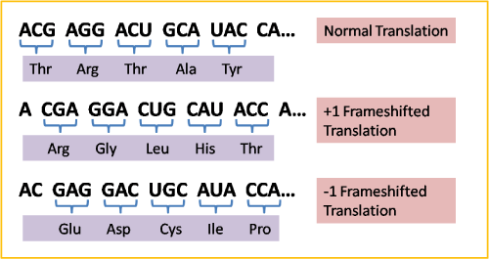
HELICASE | RNA POLYMERASE (230) | LIGASE | GYRASE
The first enzyme in transcription that unzips the double helix by breaking the hydrogen bonds between base pairs. |  | Enzyme that ‘Seals’ the original DNA strand back together following transcription | Causes the DNA strand to twist or wind back into a double helix after transcription
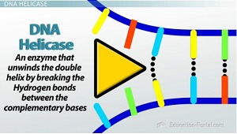  Helen the Homewrecker | 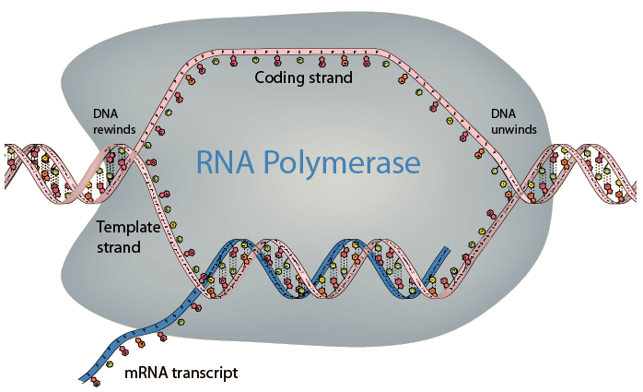  RHONDA the Date Matchmaker | Lisa the Love Spell  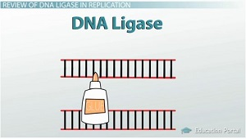 | Gina the Gymnast  